**CHAPTER 1**

**INTRODUCTION**

1. **INTRODUCTION**

The Split Nexus app is a comprehensive and user-friendly financial management application designed to simplify the process of tracking and sharing expenses within a group. The app caters to individuals who share financial responsibilities, such as roommates, friends, or colleagues, providing a seamless platform for collaborative expense management. The app is equipped with essential features, including user registration, login, budget tracking, expense recording, graphical analysis, profile management, and support for users’ queries. Let’s delve into the details of each key functionality.

* 1. **KEY FEATURES**
     1. **User Registration and Login**: Users begin by either logging in with their existing credentials or registering by providing essential details such as name, email, password, and an initial budget. The registration process ensures a secure and personalized experience for each user.
     2. **Dashboard**: Upon logging in, users are greeted with a dashboard displaying their budget, initial expenses set to 0, and remaining balance set to 0. This provides a quick overview of their financial standing.
     3. **Expense Management**: User can individually compensate expenses, categorize them, and specify details such as date and description. The app automatically calculates and updates the remaining balance, reflecting the impact of each expense on the overall budget.
     4. **Profile Management**: Users can access and update their profile information, including name, email, and password. This ensures that user details are current and accurate.
     5. **Budget Adjustment**: The “Budget feature enables users to modify their budget as needed. Conforming the change, the budget, allowing users to adapt to evolving financial circumstances.
     6. **Help and Queries**: Users seeking assistance can use the “Help” feature to raise queries and receive support. This ensures that users have access to guidance whenever needed.
     7. **Mode Selection:** Users can switch between different modes based on their preferences or specific use cases.

## **1.2 PROJECT DESCRIPTION**

Split Nexus is a comprehensive expense management application developed to address the challenge associated with dividing and overseeing shared financial obligations within social or professional circles. The primary goal of this app to provide users with a seamless and efficient solution for handling the complexities of shared expenses, offering a user-friendly interface and a range of features to enhance financial coordination.

Users of Split Nexus can easily initiate and manage expense groups tailored to specific shared activities, such as household bills, group outings, or collaborative projects. The app’s intuitive design allows participants to keep track of individuals contributions and monitor the overall financial landscapes within the group. This transparency is a key aspect of Split Nexus, aiming to foster clear communication and reduce potential misunderstandings related to shared finances.

One of the standout features of Split Nexus is its robust expense tracking system. Users can input and categorize various expenses, providing detailed information such as the nature of the cost, date and the involved participants.

This features not only aids in accurate record-keeping but also facilitates a comprehensive understanding of the financial dynamics within the group. The app’s quick bill-splitting functionalities further contribute to its efficiency. Split Nexus automates the process of dividing costs among participants, eliminating the need for manual calculations and ensuring that each member’s financial contributions accurately reflected. This automation not only saves time but also minimizes the like hood of errors in the distribution of expenses.

Real-time updates on financial contributions add another layer of convenience to Split Nexus. Participants can stay informed about the current state of shared expenses, fostering a sense of safeguard sensitive financial information, ensuring a trustworthy platform for users.

In Summary, Split Nexus is not just an expense-sharing app; it’s a comprehensive solution designed to simplify and enhances the management of shared finances. By combining intuitive design, automated functionalities, and real-time updates, Split Nexus empowers users to navigate shared financial responsibilities with ease, promoting transparency, accuracy and peace of mind.”

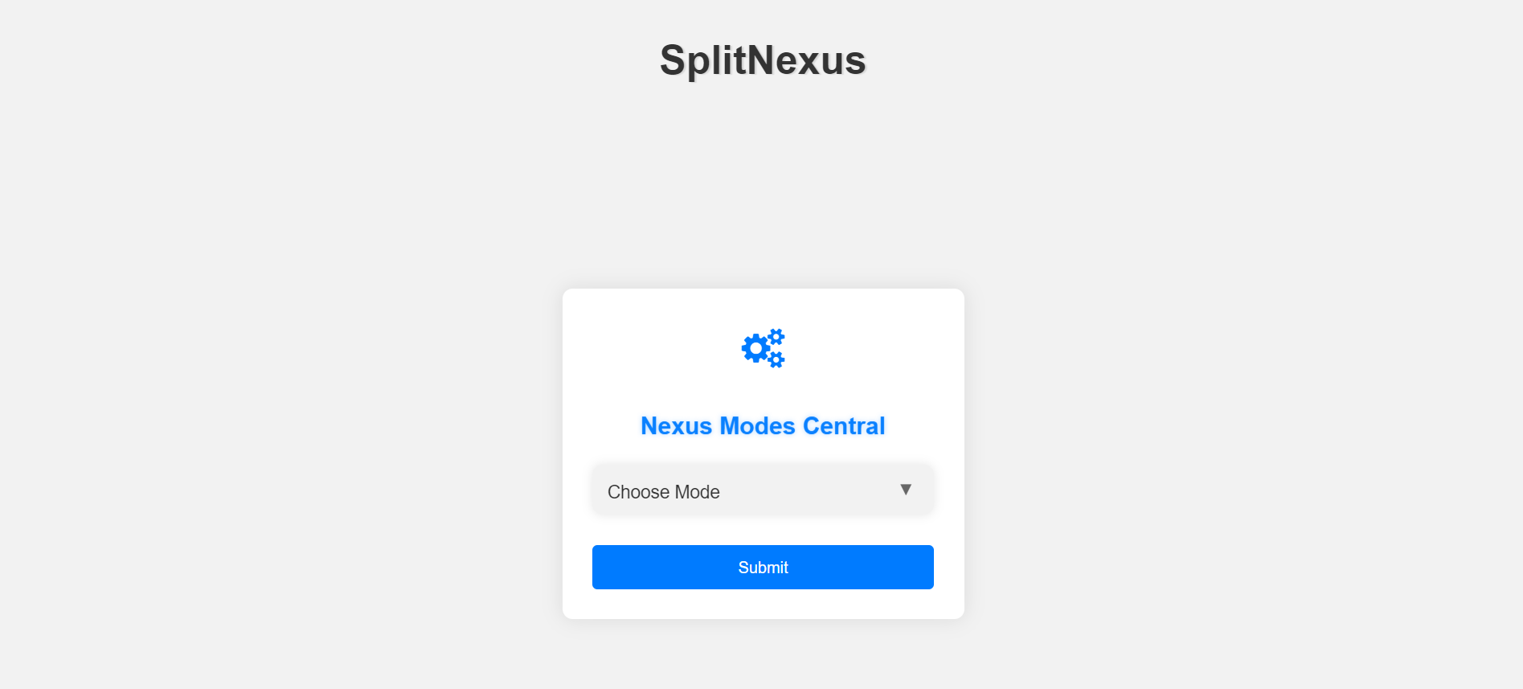

Figure 1.1 Mode Preference Unleashed - Define Your Figures, Craft Your Story

## **1.3 PROJECT SCOPE**

The project scope for Split Nexus entails the development and deployment of a comprehensive expense, and management application. Users will have the ability to register and create individual accounts, ensuring a personalized experience within the app. Robust authentication mechanisms will be implemented to safeguard user data and maintain the security of the platform.

A central feature of the app is the creation and a management of expenses groups. Users can effortlessly initiate and oversee financial collaborations related to shared activities, such as household bills, group outings, or collaborative projects. Each expense group will provide a dedicated space for participants, enabling transparent communication and coordination.

The application will boast an intuitive interface for detailed expense tracking. Users can input and categorize various expenses, including relevant details such as the nature of the cost, date and involved participants.

The features ais to streamline record-keeping and facilities a comprehensive understanding of the financial dynamics within each group.

To further enhance efficiency, the app will automate the process of splitting bills among participants. This functionality eliminates the need for manual calculations, ensuring accurate and fair distribution of expenses. Real-time updates on financial contributions will be provided, fostering a sense of accountability and collaboration within each expense group.

Overall, the Split Nexus app will offer a seamless and user-friendly solution for managing shared finances, promoting transparency, accuracy, and ease of use for individuals navigating shared financial responsibilities.

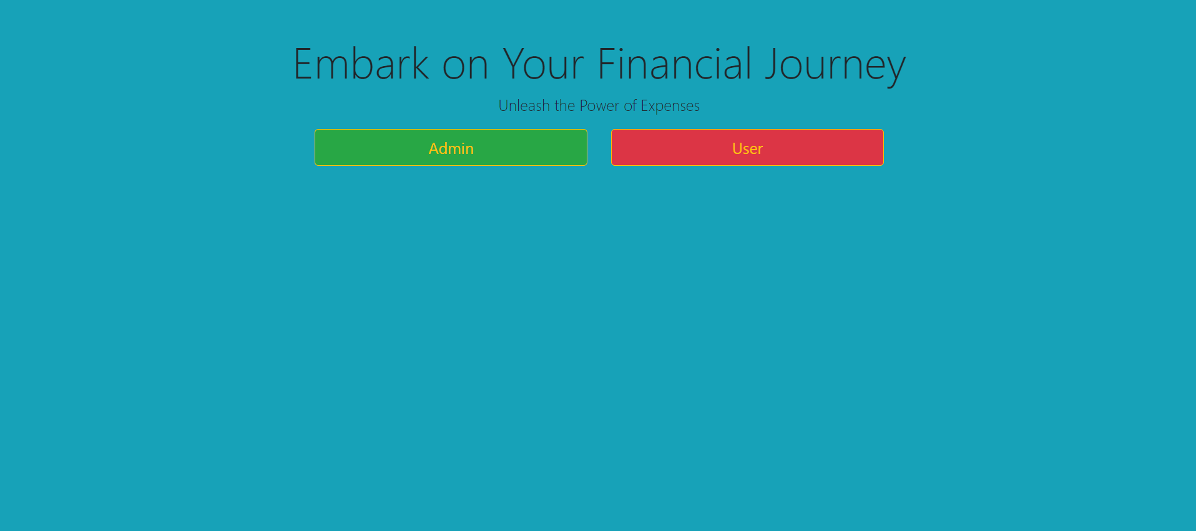

Figure 1.2 Select Role for beginning Split Nexus Journey

Automation will be a key feature, particularly in the process of splitting bills among participants. The app will employ algorithms to calculate and distribute expenses automatically, eliminating the need for manual calculations and minimizing the potential for errors. Real-time updates on financial contributions will be integrated to keep participants informed, fostering a sense of accountability and collaboration within each expense group.

## **1.4 HARDWARE / SOFTWARE USED IN PROJECT**

The Split Nexus app will involve a combination of hardware and software components to ensure its development, deployment and functionality. Here is detailed List:

**1.4.1 Server-side Hardware:**

**1. RAM (Random Access Memory):**

* 8GB to 16GB (for moderate-sized application and user load).
* Consider higher capacities (e.g., 32GB or more) for scalability and handling a large number of concurrent users.

**2. ROM (Storage):**

* SSD storage for faster read and write operations.
* Allocate storage based on the application codebase, database size, and media storage requirements.

**3. Processor:**

* Multi-core processor (quad-core or higher) for efficient handling of concurrent user requests.

**4. Operating System:**

* Linux-based operating system (e.g., Ubuntu Server, CentOS, Debian) for stability and performance.

**5. Network Equipment:**

* Network infrastructure to facilitate secure data transfer between users and the server.

**1.4.2 Database Server:**

**1. RAM:**

* 16GB or more for efficient handling of concurrent database queries.

**2. ROM(Storage):**

* SSD storage for faster data retrieval.
* Allocate storage based on the anticipated size of the database and data storage needs.

**3. Processor:**

* Multi-core processor with sufficient processing power for complex database operations.

**4. Operating System:**

* Linux-based operating system for the database server.

**1.4.3 User Devices:**

**1. Smartphones/Tablets:**

* Compatibility with iOS and Android operating systems.
* Optimization for various screen sizes and resolutions.

**2. Web Browsers:**

* Compatibility with major web browsers such as Google Chrome, Mozilla Firefox, Safari, and Microsoft Edge.

**1.4.4 Development Environment:**

**1. Programming Languages:**

* Backend: Python, Node.js or another suitable language.
* Frontend: HTML5, CSS3, JavaScript (React, Angular, Vue.js).

**2. Framework:**

* Web application framework (e.g., Flask, Django, Express.js) for backend development

**3. Database Management System:**

* Choose a suitable DBMS (e.g., MySQL, PostgreSQL, MongoDB) for efficient data storage and retrieval.

**4. Authentication and Authorization:**

* Implement secure authentication protocols (OAuth, JWT) and authorization mechanisms.

**5. APIs:**

* Develop APIs to enable communication between the frontend and backend components.

**6. Version Control:**

* Version control system (e.g., Git) for managing and tracking changes in the source code.

**7. Integrated Development Environment (IDE):**

* IDEs such as Visual Studio Code, PyCharm, or IntelliJ IDEA for coding and debugging.

**8. Containerization:**

* Containerization tools like Docker for efficient deployment and scalability.

**9. Continuous Integration/Continuous Deployment (CI/CD) :**

* CI/CD pipelines (e.g., Jenkins, Travis CI) for automated testing and deployment.

**10.Security Tools:**

* Integrate security tools and practices to ensure the application's resilience against potential threats.

**11. Monitoring Tools:**

* Monitoring tools (e.g., Prometheus, Grafana) for tracking application performance.

**12. Collaboration Tools:**

* Collaboration tools (e.g., Slack, Microsoft Teams) for effective communication among project team members.

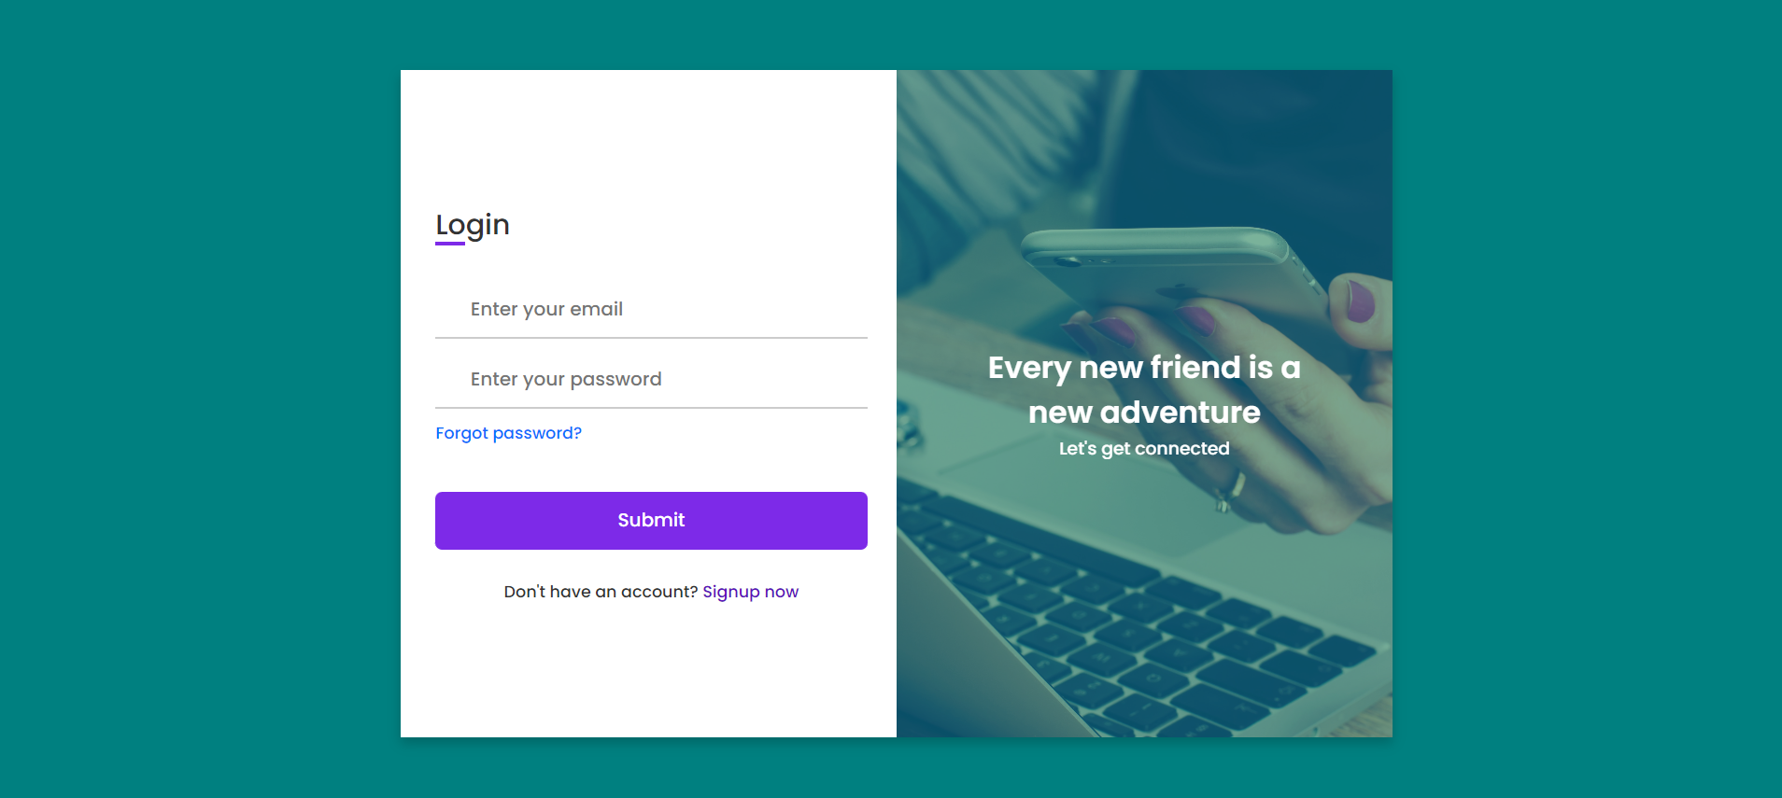

Figure 1.3 Login Credentials Web Page

**CHAPTER 2**

**FEASIBILITY STUDY**

## **2. INTRODUCTION**

The feasibility study for the Split Nexus app is a critical initial phase in the project lifecycle, aiming to assess the viability and practicality of implementing the proposed expense management solution. This study encompasses a comprehensive analysis of various aspects, including technical, economic, legal, operational, and scheduling considerations.

The introduction to the feasibility study sets the stage for understanding the rationale behind the project and outlines the key objectives of the assessment.

In an era characterized by dynamic financial interactions and collaborative living, the concept of managing shared expenses has become increasingly complex. Recognizing the need for a streamlined solution, the Split Nexus app is envisioned as a comprehensive tool to alleviate the challenges associated with dividing and managing shared financial responsibilities. This feasibility study is undertaken to evaluate the practicality and potential success of developing and implementing the Split Nexus app.

The primary objective of the feasibility study is to provide a thorough examination of the technical, economic, legal, and operational aspects involved in bringing the Split Nexus app to fruition. By conducting this study, we aim to gain insights into the project's viability, potential challenges, and anticipated benefits. The study will serve as a foundation for informed decision-making throughout the development lifecycle.

* 1. **KEY OBJECTIVES**
     1. **Technical Feasibility**:
* Assess the technical requirements and challenges associated with developing the Split Nexus app.
* Evaluate the availability of necessary technologies and expertise to implement the proposed features.
  + 1. **Economic Feasibility**:
* Examine the cost implications of developing and maintaining the Split Nexus app.
* Project the Return on Investment (ROI) and assess the financial viability of the project.
  + 1. **Legal Feasibility**:
* Investigate legal considerations, including data protection, privacy laws, and compliance requirements.
* Ensure that the development and deployment of the app adhere to regulatory standards.
  + 1. **Operational Feasibility**:
* Analyze how the Split Nexus app will integrate into existing operational processes.
* Evaluate the app's usability and acceptance by potential users.
  + 1. **Scheduling Feasibility**:
* Develop a realistic project timeline, considering the development, testing, and deployment phases.
* Identify potential bottlenecks and risks that may impact the project schedule.

**2.2 Technical Feasibility**

The technical feasibility assessment is a pivotal component of the Split Nexus app, project, focusing on the viability and capability of implementing the proposed solution from a technological standpoint.

This analysis delves into various technical aspects, including infrastructure requirements, software development considerations, and potential challenges. The goal is to ascertain whether the envisioned app can be developed effectively, leveraging available technologies and expertise.

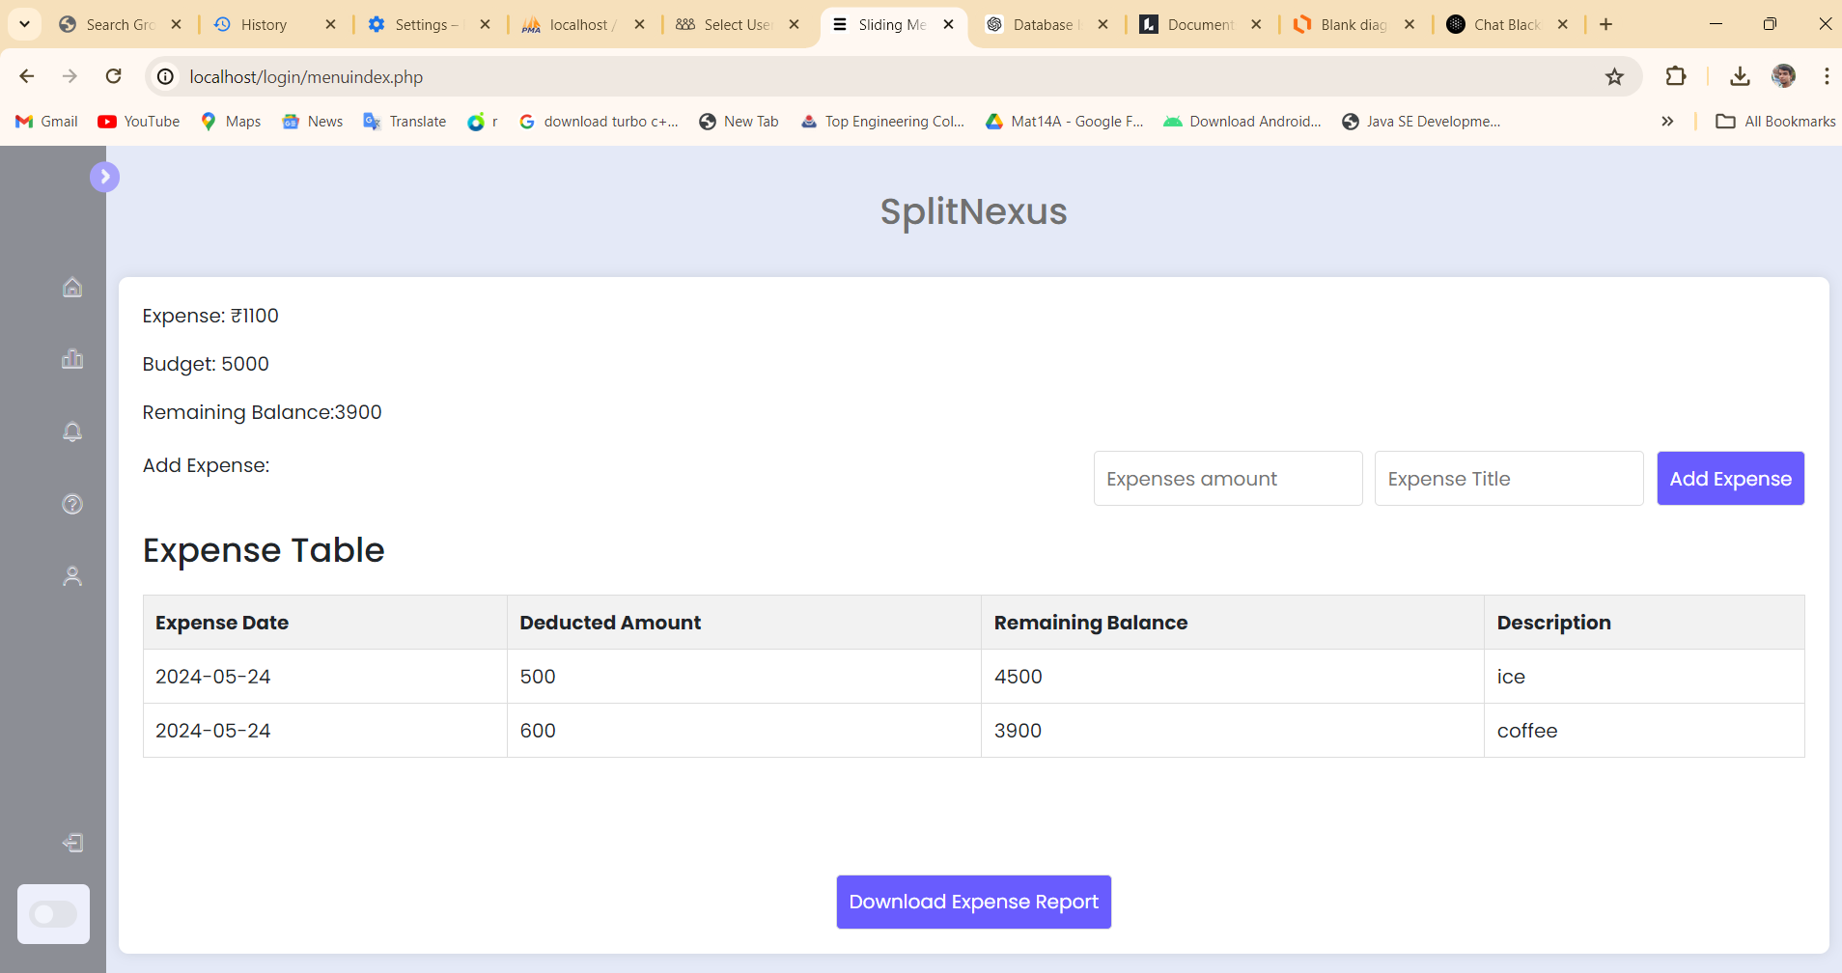

Figure 2.1 User controlled expense dashboard

**2.2.1 Infrastructure Requirements:**

* **Server Infrastructure:** Asses the capacity and scalability of cloud-based servers (e.g., AWS, Azure) to accommodate potential user growth and ensure seamless performance.
* **Database Management**: Evaluate the suitability of database systems (e.g., MySQL, PostgreSQL) for efficient storage and retrieval of user data.

**2.2.2 Software Development:**

* **Programming Languages:** Choose appropriate backend (e.g., Python, Node.js) and frontend (e.g., React, Angular) technologies based on developer expertise and project requirements.
* **Framework Selection**: Select a web application framework (e.g., Django, Flask) to streamline development and enhance maintainability.

**2.2.3 Security Measures:**

* **Authentication Protocols:** Implement secure authentication mechanisms (e.g., OAuth, JWT) to protect user accounts and ensure data security.

**2.2.4 User Interface (UI) Design:**

* **Responsive Design:** Optimize the app's UI for various devices (smartphones, tablets, web browsers) to provide a consistent and user-friendly experience.

**2.2.5 Deployment and Monitoring:**

* **Docker:** Implement containerization using Docker for efficient deployment, scalability, and consistency across different environments.

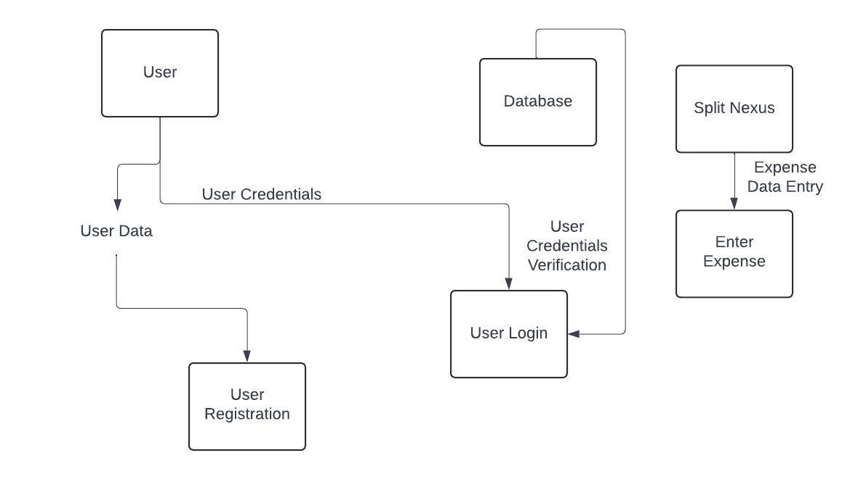

Figure 2.2 Split Nexus Architecture Diagram

**2.3 Operational Feasibility**

The operational feasibility analysis is a crucial aspect of determining whether the Split Nexus app can seamlessly integrate into existing processes and effectively meet the needs of its users.

This assessment involves evaluating usability, acceptance, and overall fractionality from and operational standpoint.

**2.3.1 User Acceptance:**

* **User Feedback Surveys:** Conduct surveys or gather feedback from potential users to gauge their acceptance of the Split Nexus app. Understand user preferences and expectations.

**2.3.1 Usability Testing:**

* **User Interface (UI) Testing:** Evaluate the user interface for intuitiveness and ease of use. Conduct usability testing to identify any potential issues in navigation or functionality.

**2.3.2 User Engagement Strategies:**

* **Communication Plans:** Develop communication strategies to keep users informed about new features, updates, and any changes in the app. Foster ongoing engagement.

**2.3.3 Operational Impact Analysis:**

* **Operational Workflow Analysis:** Assess how the Split Nexus app will fit into users' daily workflows. Identify potential impacts on existing operational processes.

**2.3.4 Change Management Strategies:**

* **Change Management Plans:** Develop strategies to manage organizational and user-level changes resulting from the introduction of the Split Nexus app. Address any potential resistance.

**2.3.5 Legal and Compliance Considerations:**

* **Compliance Analysis:** Ensure that the app complies with relevant legal and regulatory requirements related to financial transactions, data protection, and user privacy.

**2.4 Behavioral Feasibility**

The behavioral feasibility analysis of the Split Nexus app focuses on understanding and anticipating the attitudes, perceptions, and cultural dynamics that may influence user acceptance and adoption. A key consideration in the success of the app is the motivation of potential users to incorporate it into their shared financial management practices.

This involves evaluating whether users perceive the app as a valuable solution to their needs and whether it aligns with their motivations for collaborative expense management. Cultural acceptance is another critical aspect, where the app's features and communication strategies need to resonate with cultural preferences.

Adaptations may be necessary to ensure the app is well-received within diverse user communities. Effective communication strategies are vital to convey the benefits of the Split Nexus app clearly. Outreach efforts should aim to inform potential users about how the app addresses pain points and simplifies shared financial responsibilities.

Understanding and addressing resistance to change is imperative, as users may be accustomed to existing methods of expense management. Change management strategies should be implemented to ease concerns and foster a positive attitude towards adopting the app.

Moreover, user education and awareness campaigns play a pivotal role in ensuring that potential users are well-informed about the app's features and advantages. User-centric design principles guide the development of the Split Nexus app, taking into account user preferences and behaviors.

User experience research informs the refinement of the app's interface for optimal usability, creating an environment that is intuitive and engaging for a diverse user base. Consideration of social dynamics in shared living or collaborative work environments is also paramount, with the app designed to enhance social interactions related to financial activities.

To further encourage user acceptance, the app incorporates feedback mechanisms, providing users with a platform to contribute their insights. Incentive structures, such as rewards for active participation, are explored to motivate users and enhance behavioral acceptance.

The Split Nexus app also places a strong emphasis on accessibility and inclusivity, ensuring that it caters to users with diverse needs and abilities. By addressing these behavioral aspects comprehensively, the Split Nexus app seeks not only to meet the functional needs of users but also to align seamlessly with their behaviors, preferences, and motivations.

This user-centric approach is fundamental to fostering positive user attitudes, driving adoption, and ensuring the long-term success of the app in shared financial management scenarios.

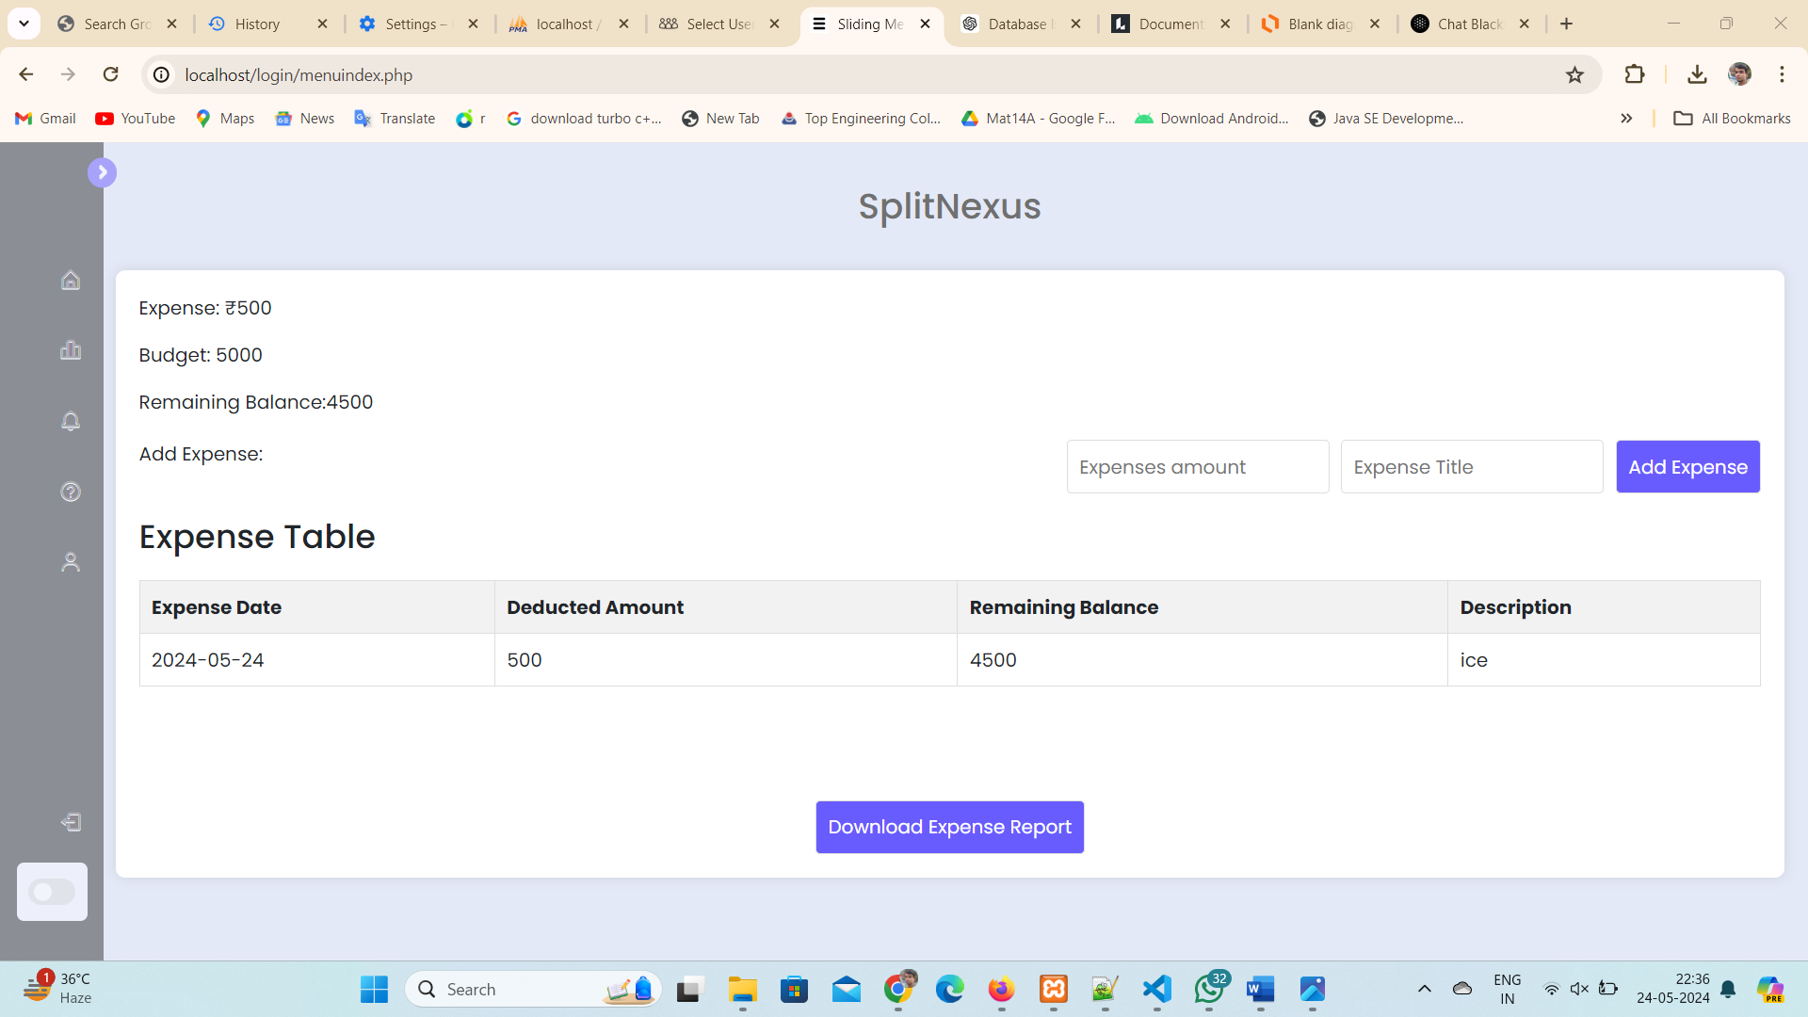

Figure 2.3 Behavioral Dashboard Change with Budget

**2.5 Schedule Feasibility**

The schedule feasibility analysis for the Split Nexus app is integral to the project's success, aiming to assess the practicality and achievability of the proposed timeline. A meticulously planned project timeline delineates key milestones, deliverables, and deadlines across the development, testing, and deployment phases. Each stage, including development, testing, and iterative cycles, undergoes detailed task breakdowns to ensure accurate time allocation for coding, testing, and refinement.

Testing and quality assurance constitute critical phases, demanding ample time for comprehensive testing, debugging, and issue resolution. Incorporating iterative development cycles and feedback loops allows for continuous refinement based on testing outcomes and user feedback. The availability of human resources, including developers and testers, is carefully considered to ascertain that team members can commit the necessary time to their respective roles.

In anticipating potential risks, the schedule feasibility analysis identifies technical challenges, resource constraints, and unforeseen issues, accompanied by mitigation strategies to minimize their impact. Exploring parallel development opportunities and incorporating contingency buffers in the schedule further fortifies the project against unexpected delays.

Effective collaboration and communication are essential components to facilitate seamless coordination among team members, ensuring timely issue resolution and adherence to the project schedule. The deployment phase is meticulously planned, encompassing server setup, data migration, and user onboarding, with allocated time to accommodate unforeseen challenges.

Finally, the schedule feasibility analysis recognizes the iterative nature of development, allowing for the integration of user feedback into the process. This iterative approach ensures that the Split Nexus app aligns closely with user expectations, resulting in a well-executed project within the stipulated timeframe.

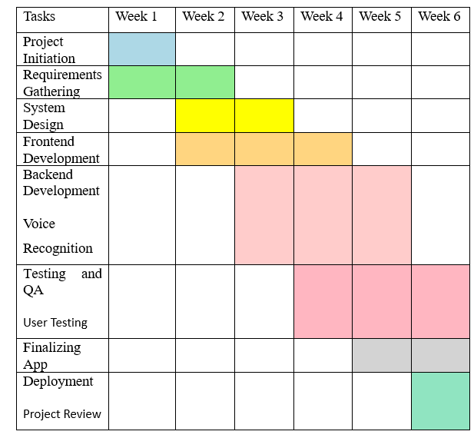

Figure 2.4 Schedule Feasibility (Gantt Chart)

**CHAPTER 3**

**DATABASE DESIGN**

## **3. INTRODUCTION**

The database design for the Split Nexus app is a foundational element that a pivotal role in organizing and managing data efficiently. A well-structured database is essential for facilitating seamless interactions between the application and its uses, ensuring robust data storage, retrieval and manipulation. The introduction outlines of the fundamental principles guiding the database design process and emphasizes the importance of creating a scalable and secure data architecture to support the diverse needs of expense management within collaborative settings.

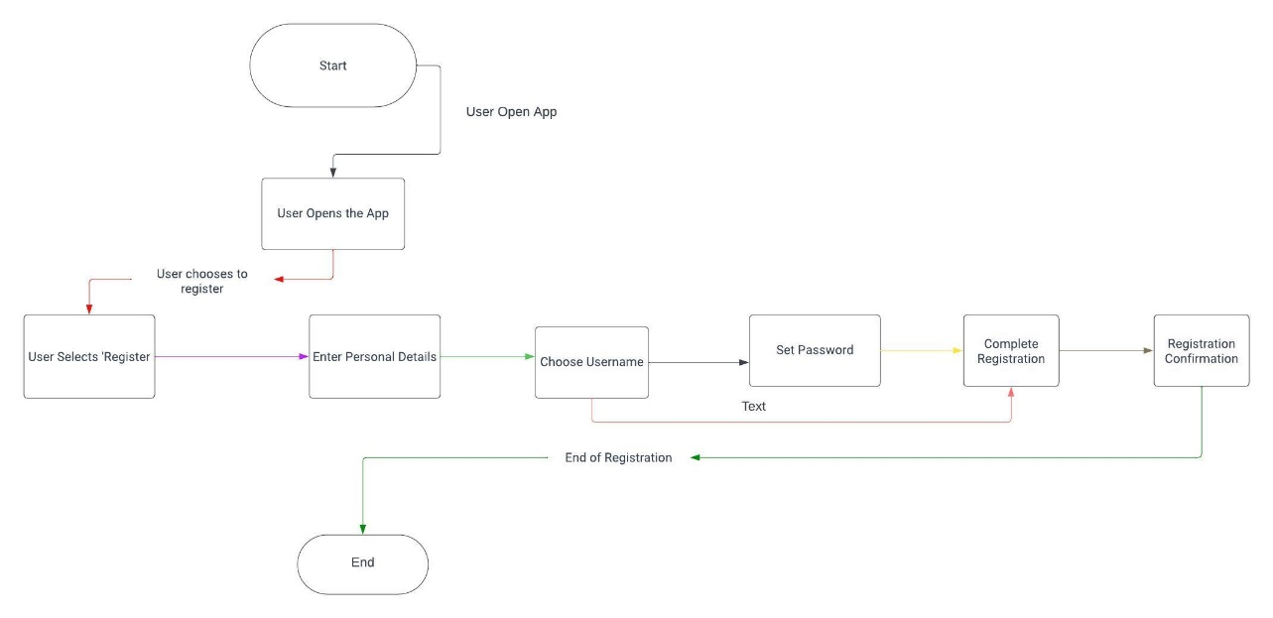

Figure 3.1 Split Nexus App Explore by User

* 1. **DATABASE TABLES**

Creating a comprehensive database table for the Split Nexus app involves

considering the key entities and their attributes. In a simplified example, let's focus on two main entities: Users and Expenses. Here's a basic representation:

* + 1. **Users Table:**
* **user_id (Primary Key):** Unique identifier for each user.
* **email:** User’s email address for communicate and login.
* **name:** User’s full name.
* **password_hash:** Securely hashed password for authentication.
* **phone number:** User’s contact number.
* **initial_budget:** The initial budget set by the user.

|  |  |  |  |  |  |
| --- | --- | --- | --- | --- | --- |
| user_id | Email | name | password_hash | phone number | Initial_budget |
| 1 | anmol.goyal2097@gmail.com | Anmol | #2122223fsdx | 9368563885 | 6000 |
| 2 | [a@gmail.com](mailto:a@gmail.com) | Abhir | #3c2223rsdx | 8321563885 | 6000 |
| 3 | anmol.goyal2097@gmail.com | Anmol | #2122253ftdx | 9462563885 | 10000 |

Figure 3.1. User's Table

* + 1. **Expenses Table:**
* **Expense Date:** Date when the expense was incurred.
* **Deducted Amount:** Amount deducted from user’s initial budget.
* **Remaining Balance:** Balance left deducting expenses.
* **Description:**  Tilte for each budget expenses
* **User name:** Anmol
* **Budget:** 5900

|  |  |  |  |
| --- | --- | --- | --- |
| **Expense Date** | **Deducted Amount** | **Remaining Balance** | **Description** |
| 2024-01-09 | 1000 | 4500 | Coffee party |
| 2023-01-09 | 1000 | 3800 | College fees |
| 2024-02-09 | 100 | 3600 | Rent |

Figure 3.2. Expense's Table

* 1. **FLOWCHART**

**Introduction to the Flowchart for Split Nexus app:**

The flowchart for the Split Nexus app encapsulates the intricate

sequence of actions and decision points involved in its operation, providing a visual roadmap for understanding the systematic flow of activities. At its core, the flowchart delineates the stepwise processes initiated by user interactions, the validation and categorization of expense data, communication with the database, and the subsequent generation and presentation of expense reports.

Commencing with the entry point, often represented by the user’s interaction, the flowchart systematically guides through essential processes such as user registration, login, expense entry, and report generation. Decision points within the flowchart capture instances where the system evaluates conditions, such as validating user data or verifying login credentials, influencing the subsequent course of actions. Key processes, depicted in distinct shapes and connected by arrows, convey the logical flow from one operation to another.

For instance, the flowchart delineates how the Split Nexus app communicates with the database for tasks like storing and retrieving user and expense data. Decision diamonds illustrate branches in the logic, signifying points where the system evaluates conditions and proceeds accordingly.

This visual representation not only aids developers in understanding the operational logic but also serves as a valuable tool for stakeholders to grasp the intricacies of the Split Nexus app's functionality. The flowchart serves as a blueprint, guiding the development team through the systematic execution of tasks, ensuring that the application functions cohesively and efficiently. Ultimately, the Split Nexus app's flowchart is a pivotal resource in comprehending, communicating, and refining the logical sequence of processes within the system.

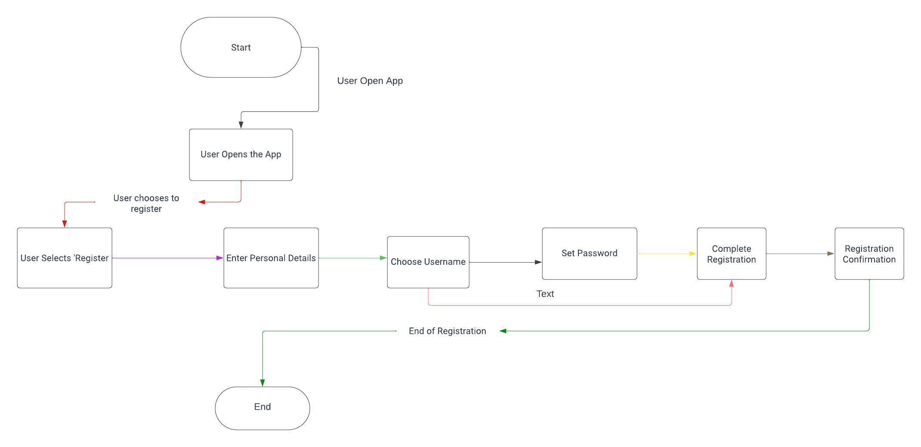

Figure 3.2 Flowchart Diagram for Split Nexus App

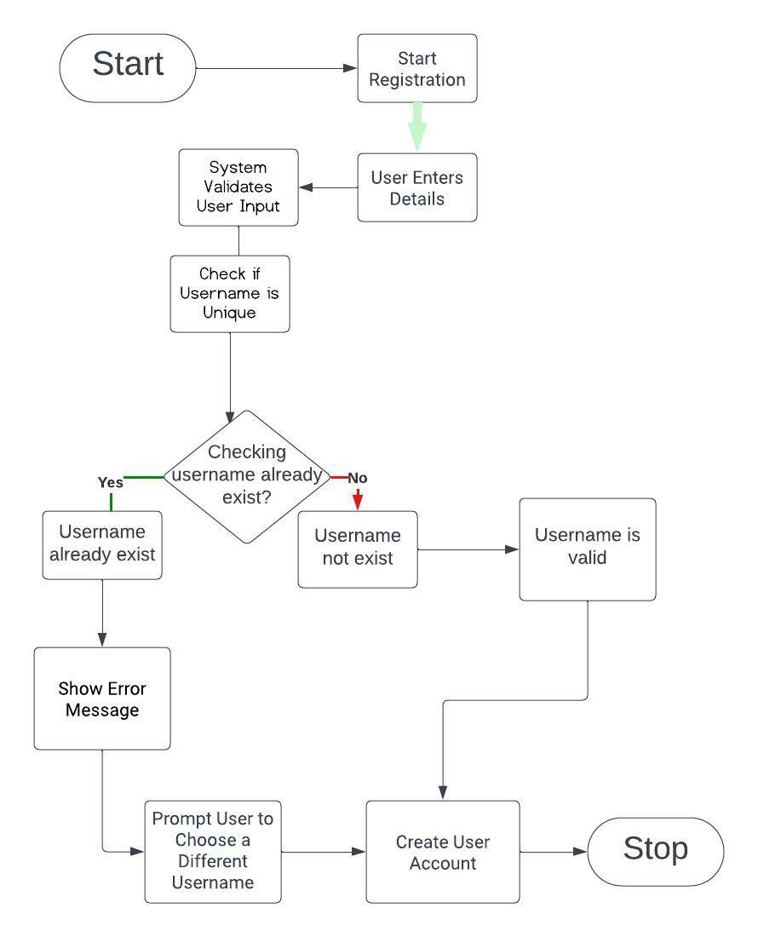

Figure 3.3 Flowchart Diagram Split Nexus App Login

* 1. **USE CASE DIAGRAM**

The Use Case Diagram for the Split Nexus app serves as an

illustrative depiction of the key functionalities and interactions between various actors within the system. Central to this diagram are the primary actors—the "User" and the "Split Nexus app"—with the "Database" playing a supportive role.

The "User" actor, representing individuals engaging with the application, initiates essential use cases such as registering an account, logging in, entering expenses, viewing detailed reports, generating summaries, and securely logging out.

On the other side, the "Split Nexus app" actor, the central application facilitating these interactions, undertakes critical use cases like validating user data during registration, creating user accounts, verifying user credentials during login, handling expense entry and categorization, and retrieving data for reporting purposes. The "Database" actor, as an external entity, collaborates with the Split Nexus app to store user and expense data, forming a cohesive system. This Use Case Diagram provides a high-level overview of the system's behavior, offering a foundational understanding for stakeholders, developers, and designers as they navigate the development and interaction aspects of the Split Nexus app.

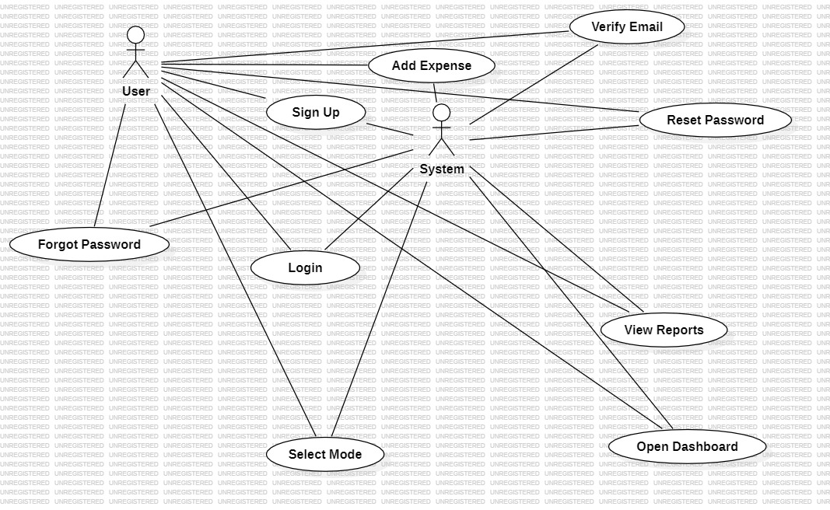

Figure 3.4 Use Case diagram for Split Nexus App

* + 1. **Actors:**
* User
* System
  + 1. **Use Case**
* Select Mode
* Login
* Forgot Password
* Reset Password
* Sign Up
* Verify Email
* Open Dashboard
* Add Expense
* View Reports

In the Split Nexus app, when the user opens the mode selection web page, they encounter two modes: normal mode and voice recognition mode. If the user clicks on normal mode, a login page appears where the user is prompted to enter their email and password. After entering the credentials, the user clicks on the login button, leading them to the dashboard. In the event that a user forgets their password, they can initiate the password reset process. The user is required to enter their email, and a verification code is sent to their email address.

After receiving the verification code, the user enters it and then proceeds to reset their password. Once the new password is set, the user can log in using the updated credentials.

For users who do not have an account, they can click on the signup option. During signup, the user is prompted to provide details such as their name, email, password, and budget limit. After entering this information, a verification code is sent to the user's email.

Upon entering the verification code and clicking on signup, the dashboard opens. Initially, the spending limit is set to 0, and the budget limit is based on the user's input. Within the app, there is a button to add expenses. When the user incurs an expense, they enter the expense details, including the amount and description. The app deducts the entered amount from the budget. After adding the expense, a chart displaying the budget limit and spending limit is updated.

If a user wishes to review their transaction history, they can click on the report option. This allows the user to access and view their transaction report.

* 1. **DATA FLOW DIAGRAM**

The Data Flow Diagram (DFD) for the Split Nexus app provides a

visual representation of the flow of data within the system, illustrating how information moves between various components. At its core, the DFD encapsulates the key processes, data stores, and data flows involved in the expense management application. Starting with user inputs, such as registering, logging in, and entering expense details, the diagram delineates how these interactions trigger processes like data validation, expense calculations, and database updates. The DFD also portrays the storage and retrieval of user data in the database, emphasizing the seamless exchange of information between users and the application.

By encapsulating the fundamental data movements and transformations, the DFD serves as a valuable blueprint for understanding the Split Nexus app's operational dynamics.

**3.4.1 Level 0 Data Flow Diagram**

Level 0 Data Flow Diagram will explain the basic flow of data in a system

in which shows how user interacts and perform the app functionality.



Figure 3.5 Level 0 DFD of Split Nexus App

The Level 0 Data Flow Diagram (DFD), also known as the Context Diagram **(Fig. 3)**, serves as a high-level representation of the Split Nexus app system, portraying it as a singular process and illustrating the interactions between the system and external entities. The primary entities involved in this context are the User, the Database (where expense data is stored), and the Split Nexus app itself.

**3.4.1.2 Entities:**

* **User:** Represents the individuals utilizing the Split Nexus app for tasks such as registration, expense entry, and reporting.
* **Split Nexus app:** Represents the central application that users interact with to perform various tasks related to expense management.
* **Database:** Signifies the repository where expense data is stored, facilitating secure and organized data management.

**3.4.1.3 Processes:**

* **User Interaction with the Split Nexus app:** This process encapsulates the various tasks that users can perform within the Split Nexus app, including registration, expense entry, and report generation.
* **Communication with the Database:** The Split Nexus app communicates with the Database to store and retrieve expense data efficiently, ensuring data accuracy and consistency.
  + - 1. **Data Flow:**
* Users input and retrieve data directly from the Split Nexus app, enabling seamless interaction and data manipulation within the application.
  + 1. **Level 1 Data Flow Diagram**

At the more detailed Level 1 Data Flow Diagram (DFD), the User

process is systematically broken down into distinct sub-processes, offering a granular view of the specific task’s users can perform within the Split Nexus app. This detailed breakdown further refines the interactions between the User, Database, and Split Nexus app entities.

**3.4.2.1 Entities:**

* **User:** Represents individuals engaging with the Split Nexus app for various tasks.
* **Database:** The storage facility for expense data, ensuring secure and organized data management.
* **Split Nexus app:** The central application facilitating user interactions and managing communication with the database.
  + - 1. **Processes:**
* **User Registration:** Sub-process wherein a user registers on the Split Nexus app by providing necessary details. Involves validation of user-provided information and updating the database with new user details.
* **User Login:** Sub-process allowing registered users to log into the Split Nexus app securely.Involves user authentication and validation against stored credentials in the database.
* **Enter Expense:** Sub-process enabling users to input new expense data into the Split Nexus app. Involves validation of entered expense details and updating the database with the new expense entry.
* **View Expense Report:** Sub-process where users can retrieve and view detailed reports of their expenses. Involves querying the database for relevant expense data and presenting it to the user through the Split Nexus app.
* **Generate Expense Summary:** Sub-process allowing users to generate summarized views of their expenses. Involves processing and aggregating expense data from the database to present concise summaries.
* **Logout:** Sub-process enabling users to securely log out of the Split Nexus app. Ensures the proper termination of the user session.
  + - 1. **Data Flow:**
* Users interact with the Split Nexus app to execute specific tasks, ranging from registration to generating expense summaries.
* The Split Nexus app, acting as the intermediary process, communicates with the Database to retrieve or update expense data based on user actions.
* For instance, during User Registration, user details are sent to the Database for storage.
  + 1. **Level 2 Data Flow Diagram**

At the Level 2 Data Flow Diagram (DFD), the detailed breakdown

of each user process provides a more intricate view of the sub-processes involved in specific tasks within the Split Nexus app. This level of detail offers insights into the intricacies of data flow and interactions between the User, Database, and Split Nexus app entities**.**

**3.4.2.1 Entities:**

* **User:** Represents individuals interacting with the Split Nexus app for various tasks.
* **Database:** The storage facility for expense and user data, ensuring secure and organized data management.
* **Split Nexus app:** The central application facilitating user interactions and managing communication with the database.
  + - 1. **Processes:**
* **User Registration:**
* **Validate User Data:** Sub-process involves checking the validity of user-provided information during the registration process.
  + **Create User Account:** Sub-process for creating a new user account, involving the storage of validated user data in the database.
* **User Login:** 
  + **Verify User Credentials:** Sub-process for authenticating user credentials during the login process.
* **Enter Expense:** 
  + **Validate Expense Data:** Sub-process ensuring the accuracy and integrity of the entered expense data.
  + **Categorize Expense:** Sub-process involving the selection and assignment of expense categories for better organization.
* **View Expense Report:**
* **Calculate Expense Totals:** Sub-process involving the computation of total expenses based on the retrieved data.
  + **Generate Summary Report:** Sub-process for creating a summarized report based on the calculated totals.
* **Generate Expense Summary:** 
  + **Calculate Expense Totals:** Sub-process involving the computation of total expenses based on the retrieved data.
  + **Generate Summary Report:** Sub-process for creating a summarized report based on the calculated totals.
  + **Logout:** Sub-process enabling users to securely log out of the Split Nexus app, terminating the user session.
    - 1. **Data Flow:**
* Each sub-process communicates with the Split Nexus app and may involve interactions with the database.
* For instance, during User Registration, the validated user data is communicated to the Split Nexus app, which, in turn, communicates with the database to store the new user account.

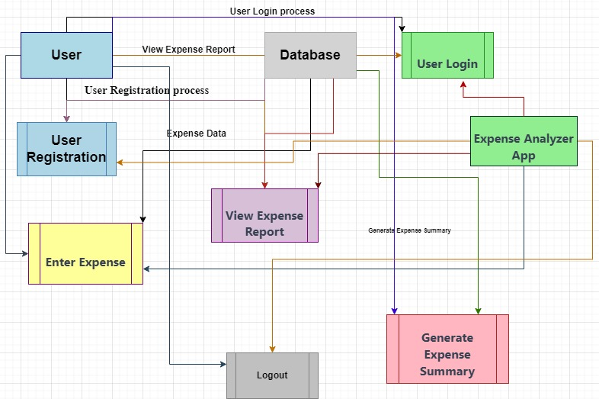

Figure 3.6 Level 2 DFD of Split Nexus App

**CHAPTER 4**

**FORM DESIGN**

1. **INTRODUCTION**

The form design for the Split Nexus app is a fundamental aspect that governs the user interface, providing a structured and intuitive framework for users to input and interact with data. This design aims to create a seamless and user-friendly experience by organizing elements such as text fields, dropdowns, and buttons in a visually appealing and logically arranged manner. Users engage with the form to register, log in, and input expense details, and the design emphasizes clarity, simplicity, and efficiency in capturing accurate information. By carefully considering user input requirements, validation processes, and responsive design principles, the form design ensures a positive user experience, encouraging user engagement and fostering effective communication between users and the application.

The registration and login forms are designed with a clean and simple layout, featuring input fields for username, email, password, and password confirmation, which are clearly labeled to guide users through the process. Real-time validation and error messages help users correct mistakes quickly, enhancing the overall experience and reducing frustration. Security measures such as password strength indicators and CAPTCHA implementation prevent automated submissions and ensure user data safety. For expense entry, users can utilize voice-activated input or manually enter expenses. The form includes fields for the amount, date, category, location, and description, with a dedicated button for activating voice input. Additionally, the geo-limit enforcement feature allows users to set geographical spending limits, incorporating a map interface for selecting areas and setting limits.

The budget management form enables users to allocate budgets to different categories, featuring dropdown menus for categories and input fields for budget amounts. Visual aids such as pie charts and bar graphs provide clear overviews of budget allocations and spending patterns. Users can also set up notifications for when spending approaches or exceeds the allocated budget in specific categories or areas. For group expense management, users can create and manage groups, invite members, and input shared expenses, which the form automatically splits among group members based on specified methods. Individual member balances are displayed for easy tracking.

The profile management form allows users to update personal information, set preferences for notifications and privacy settings, and manage security settings, including password changes and two-factor authentication. The form design adheres to principles of clarity, simplicity, consistency, responsive design, and accessibility. Clear labels, concise instructions, and effective use of whitespace prevent clutter and enhance readability. Consistent layouts and styles across forms create a cohesive user experience, while responsive design ensures optimal functionality on various devices.

Accessibility features, such as proper labeling, keyboard navigation support, and screen reader compatibility, make the forms usable for all users. Real-time feedback mechanisms, including inline validation and dynamic error messages, guide users through the data entry process, preventing errors and improving overall satisfaction.

By incorporating these elements and design principles, the form design for the Split Nexus app aims to provide a seamless, efficient, and user-friendly interface that enhances user engagement and satisfaction. The thoughtful organization of form components, robust validation, and responsive design ensure that users can easily and accurately input data, manage expenses, and interact with the application across various devices and use cases.



Figure 4.1 Users/Admin login Credentials form

## **4.1 INPUT/OUTPUT FORM (Screenshot)**

* + 1. **Mode Selection Form**

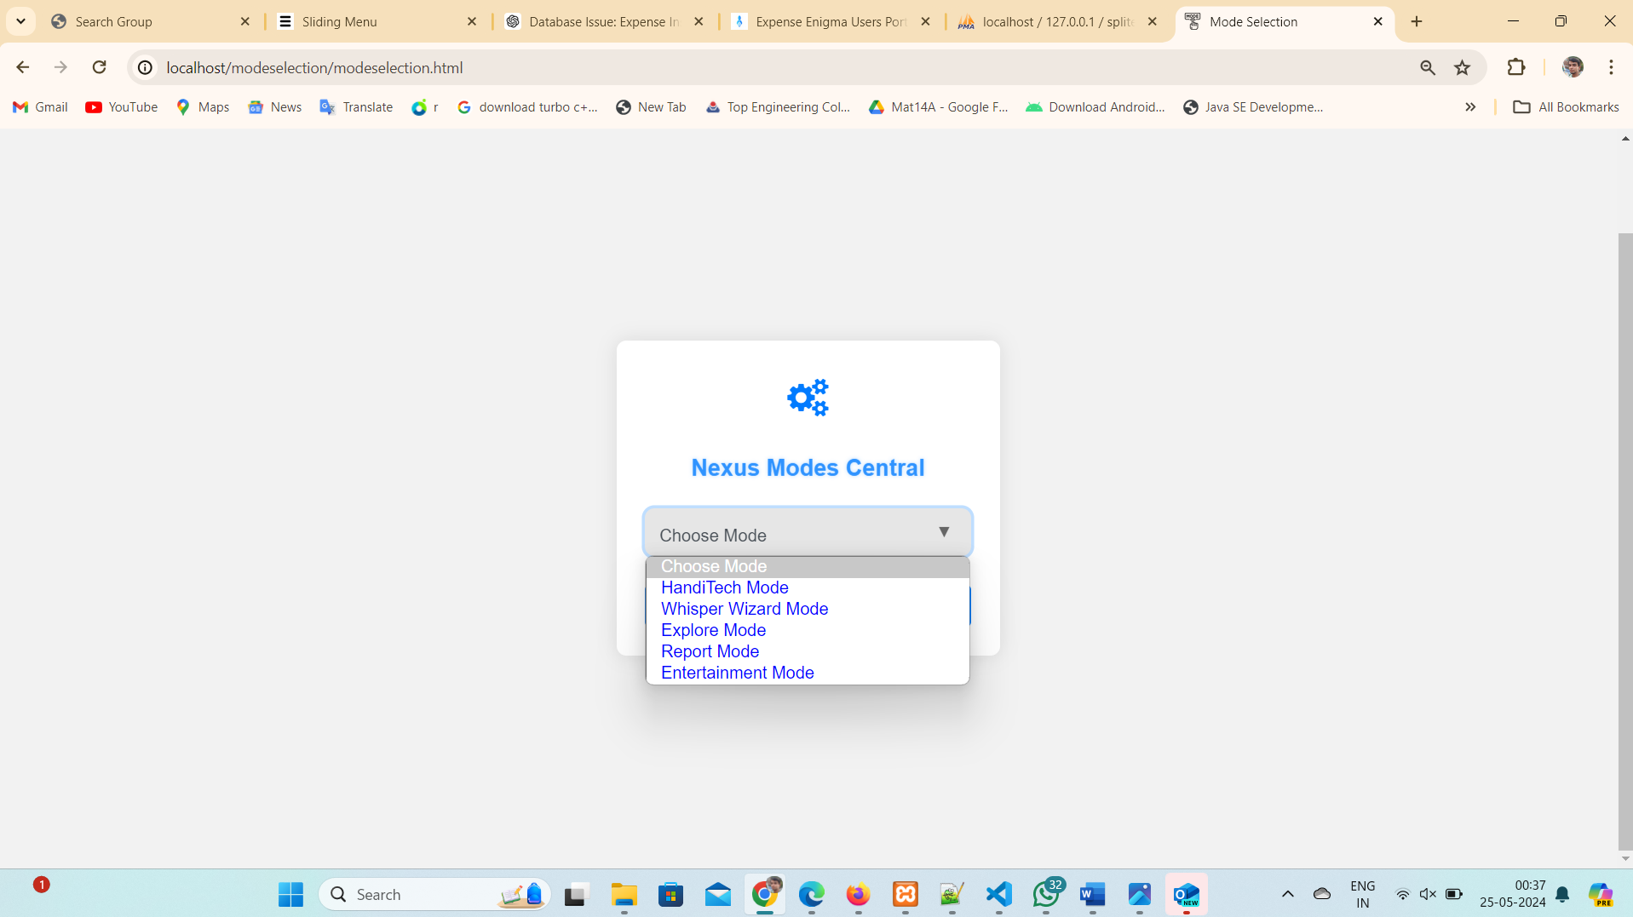

Figure 4.2 Initially user select Mode Preference

**MODE SELECTION**

* + 1. **HandiTech Mode**

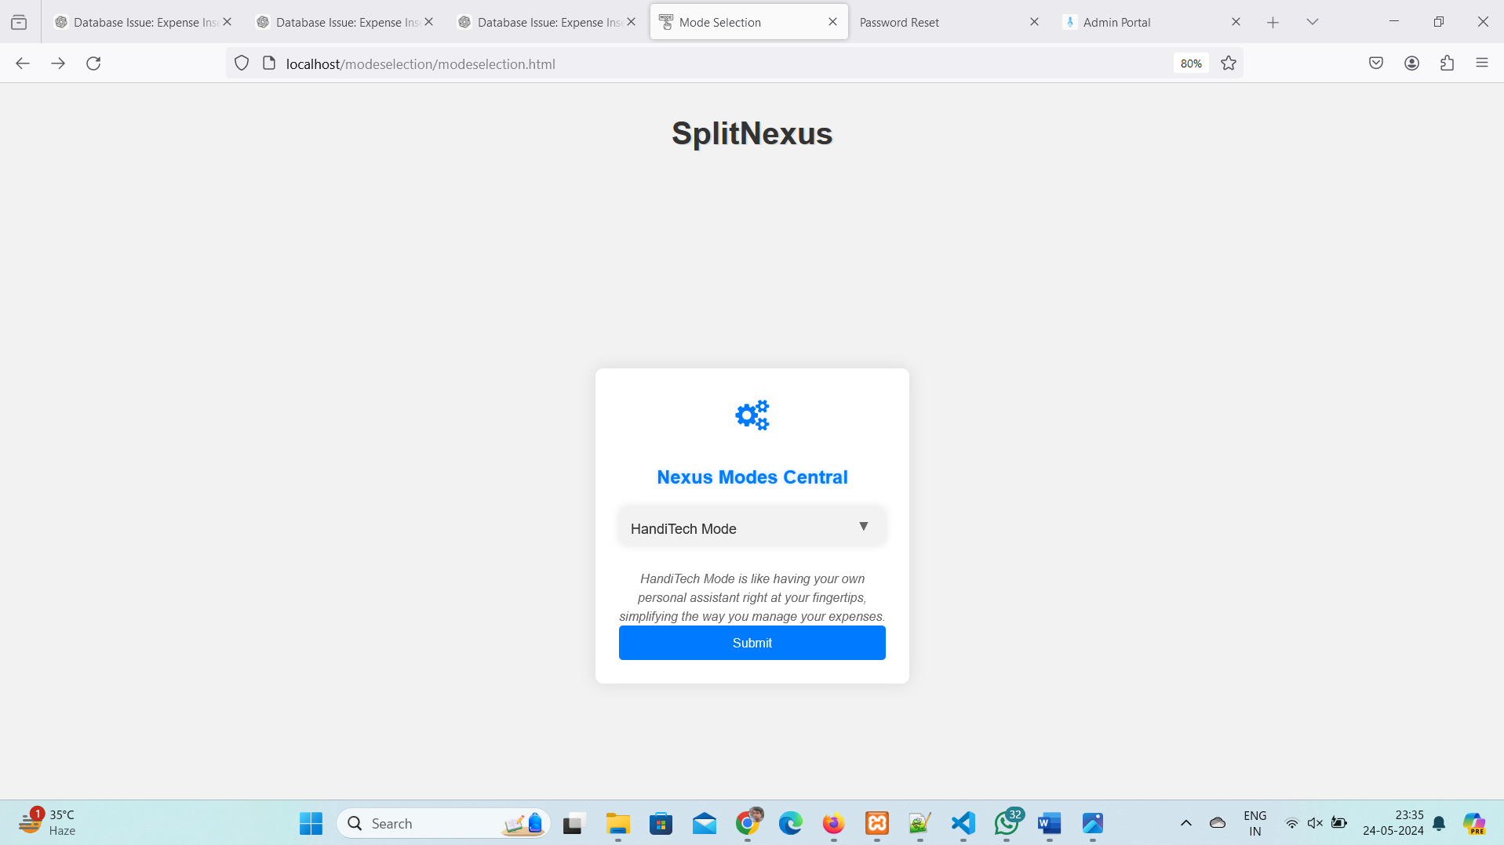

Figure 4.3 HandiTech Mode Selected

* + 1. **Role Selection Form**



Figure 4.4 Select Role either: User, Admin

* + 1. **Admin Module:** Admin can login with the Credentials
* **Email:** [anmol@gmail.com](mailto:anmol@gmail.com)
* **Password: Anmol@1819**
* If admin entered incorrect credentials, then alert will generate but if credentials are matched with the admin credentials then admin can login.

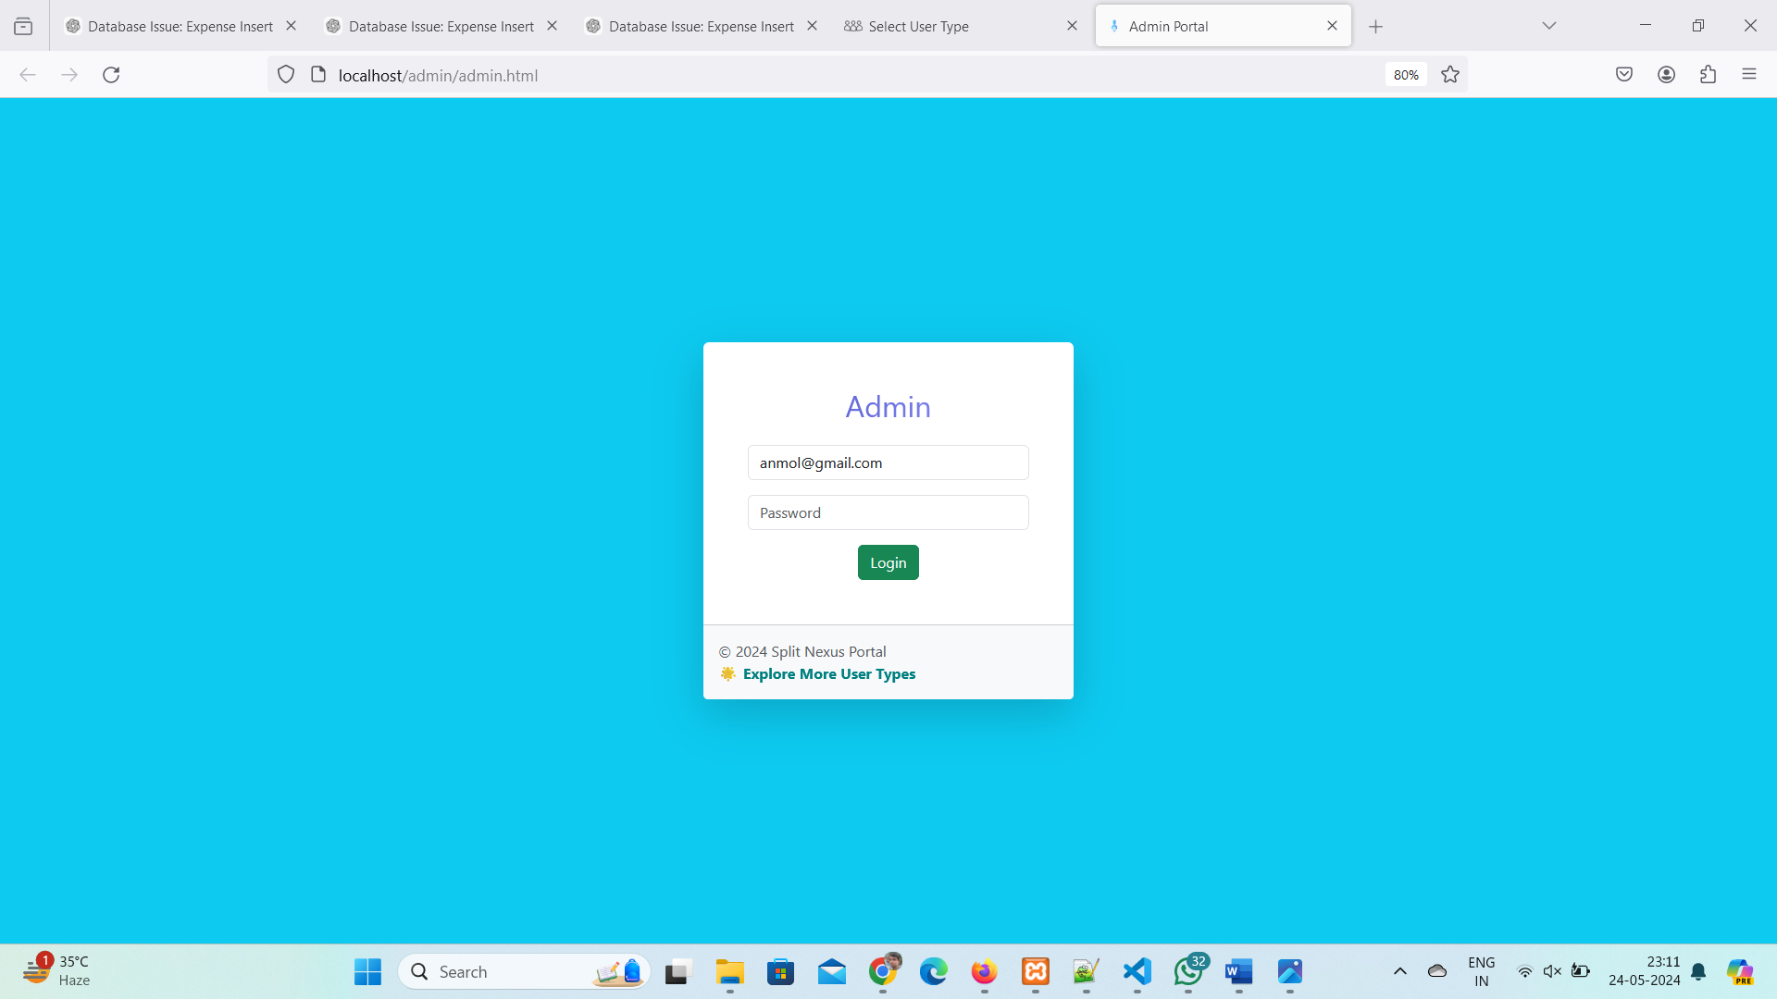

Figure 4.5 Admin Entered Correct Credentials

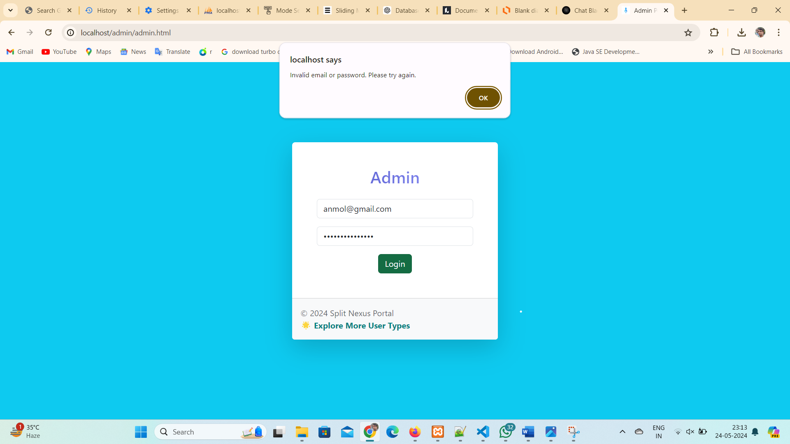

Figure 4.6 Admin Entered Wrong Credentials

**4.1.5 Admin Dashboard:**

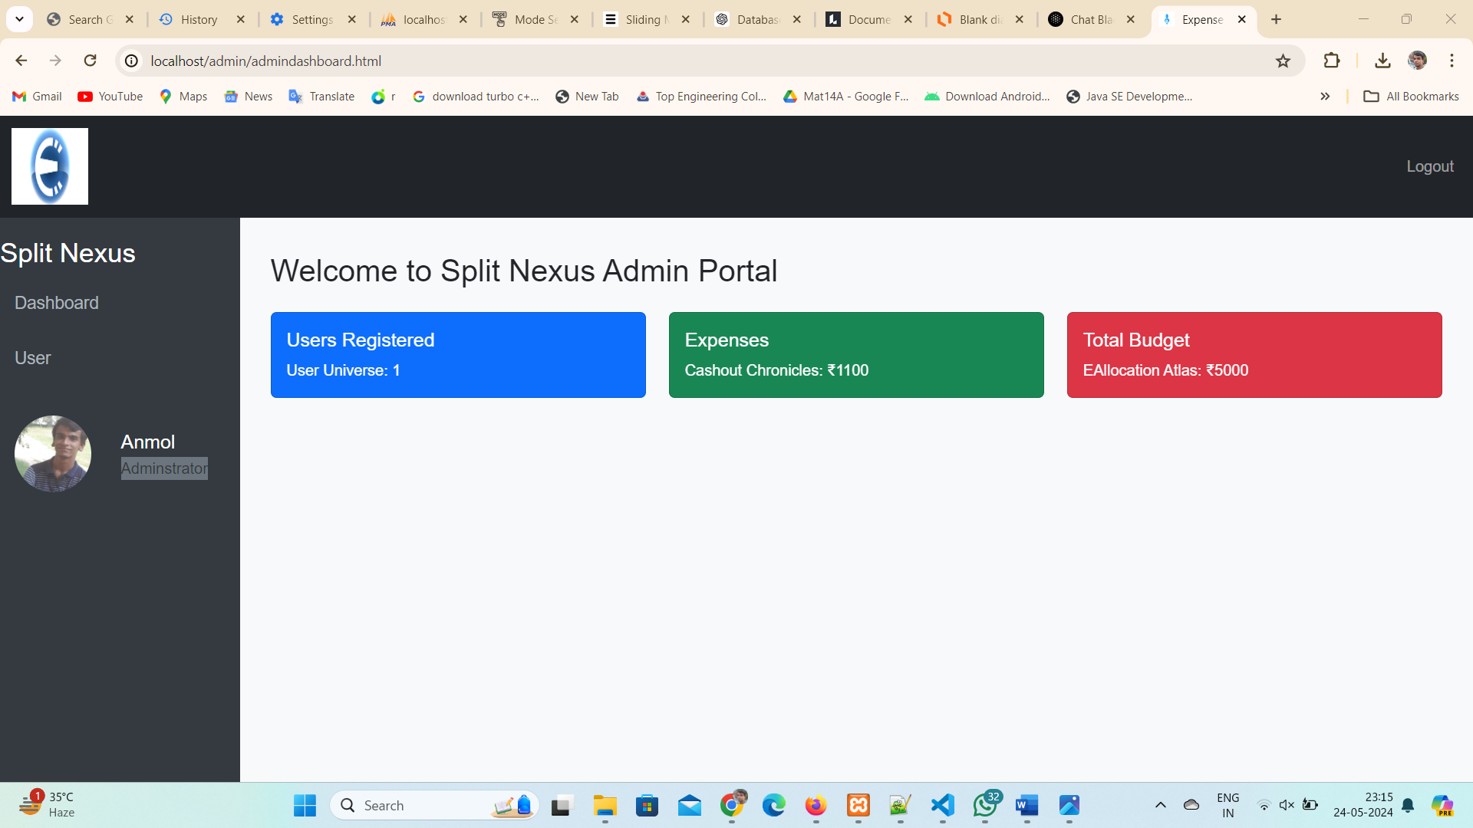

Figure 4.7 Admin Dashboard

**4.1.6 Admin- users Dashboard:**

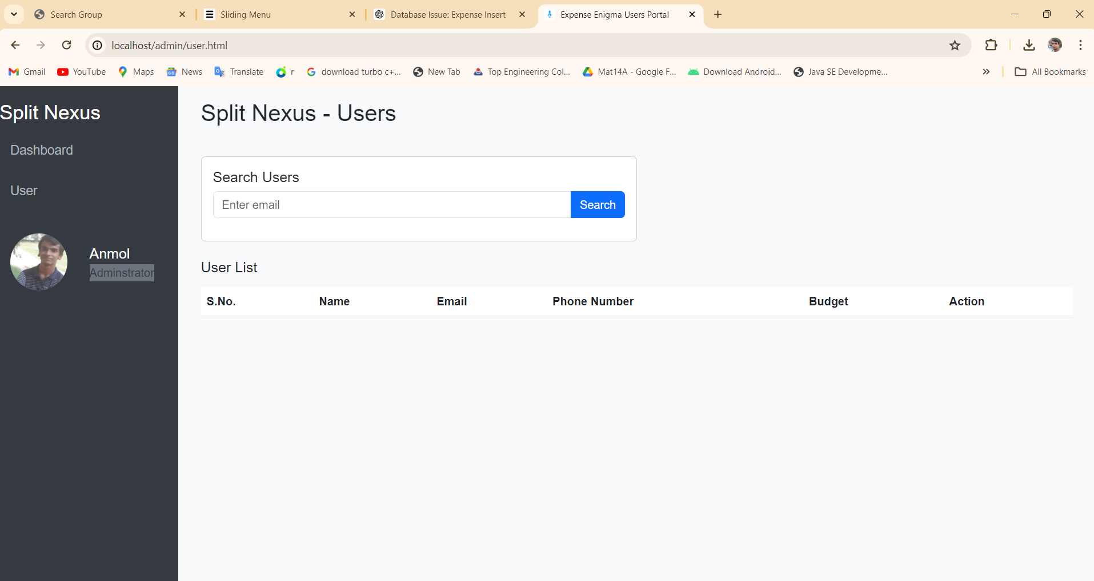

Figure 4.8 Admin-user Dashboard

**4.1.7 User Login Form:**

* **Email:** User has to enter their email for login in Split Nexus App.
* **Password:** User enter the password which they have enter during registration.
* **Forgot Password:** If user forget his password, then user click on forget password. After clicking on forget password the user has to enter the email then a verification link will be come to user email for resetting the password.
* **Update Password:** User can update their password through reset password option.

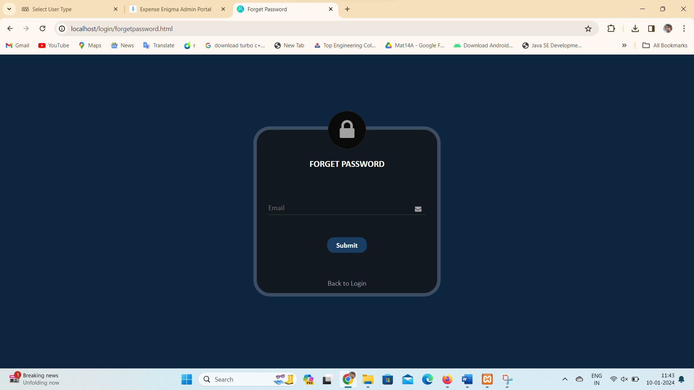

Figure 4.9 Forget Password Module

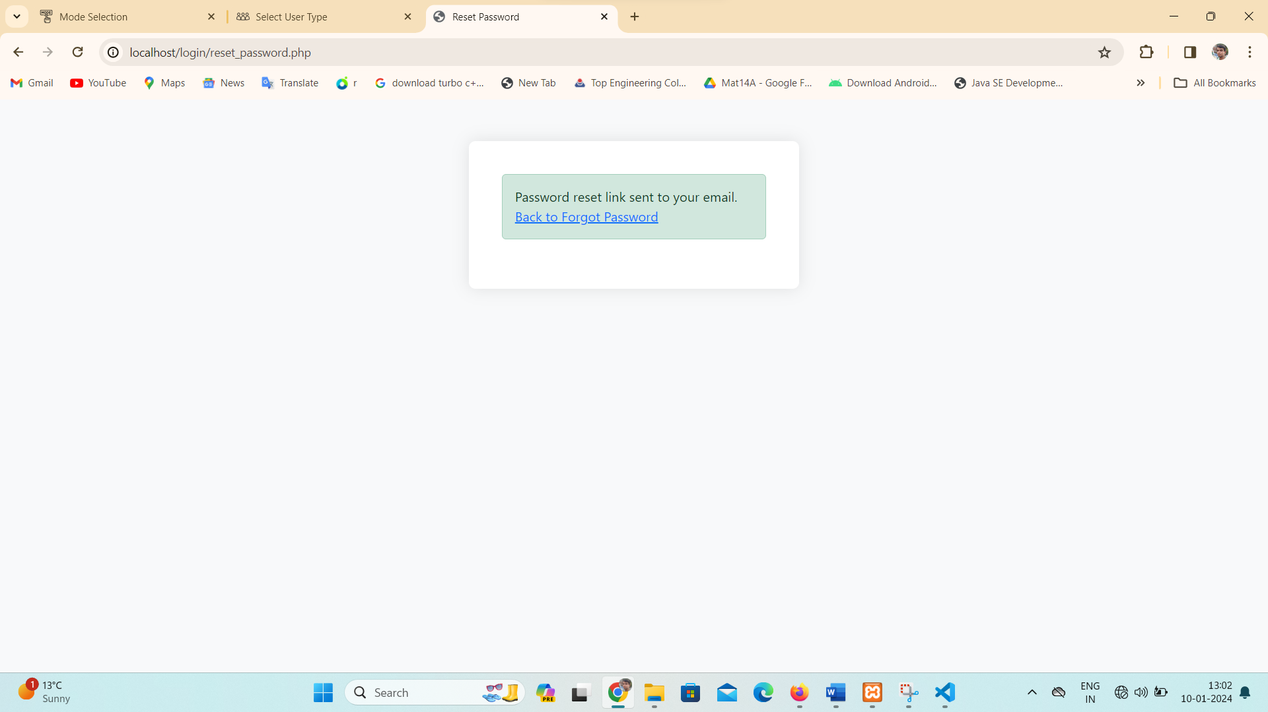

Figure 5.1 Password Reset Link Generate

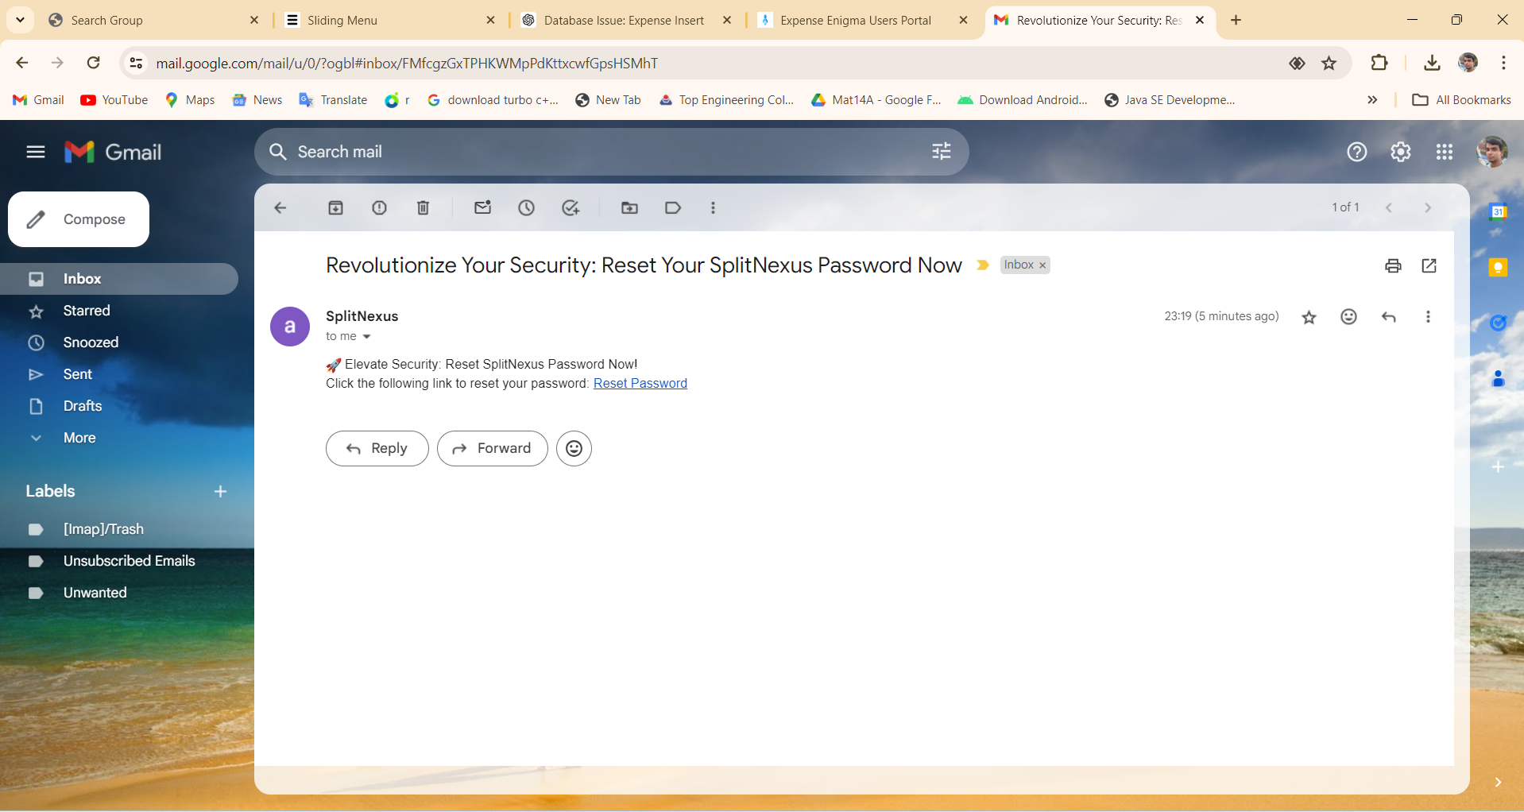

Figure 5.2 Email Reset Link Generate

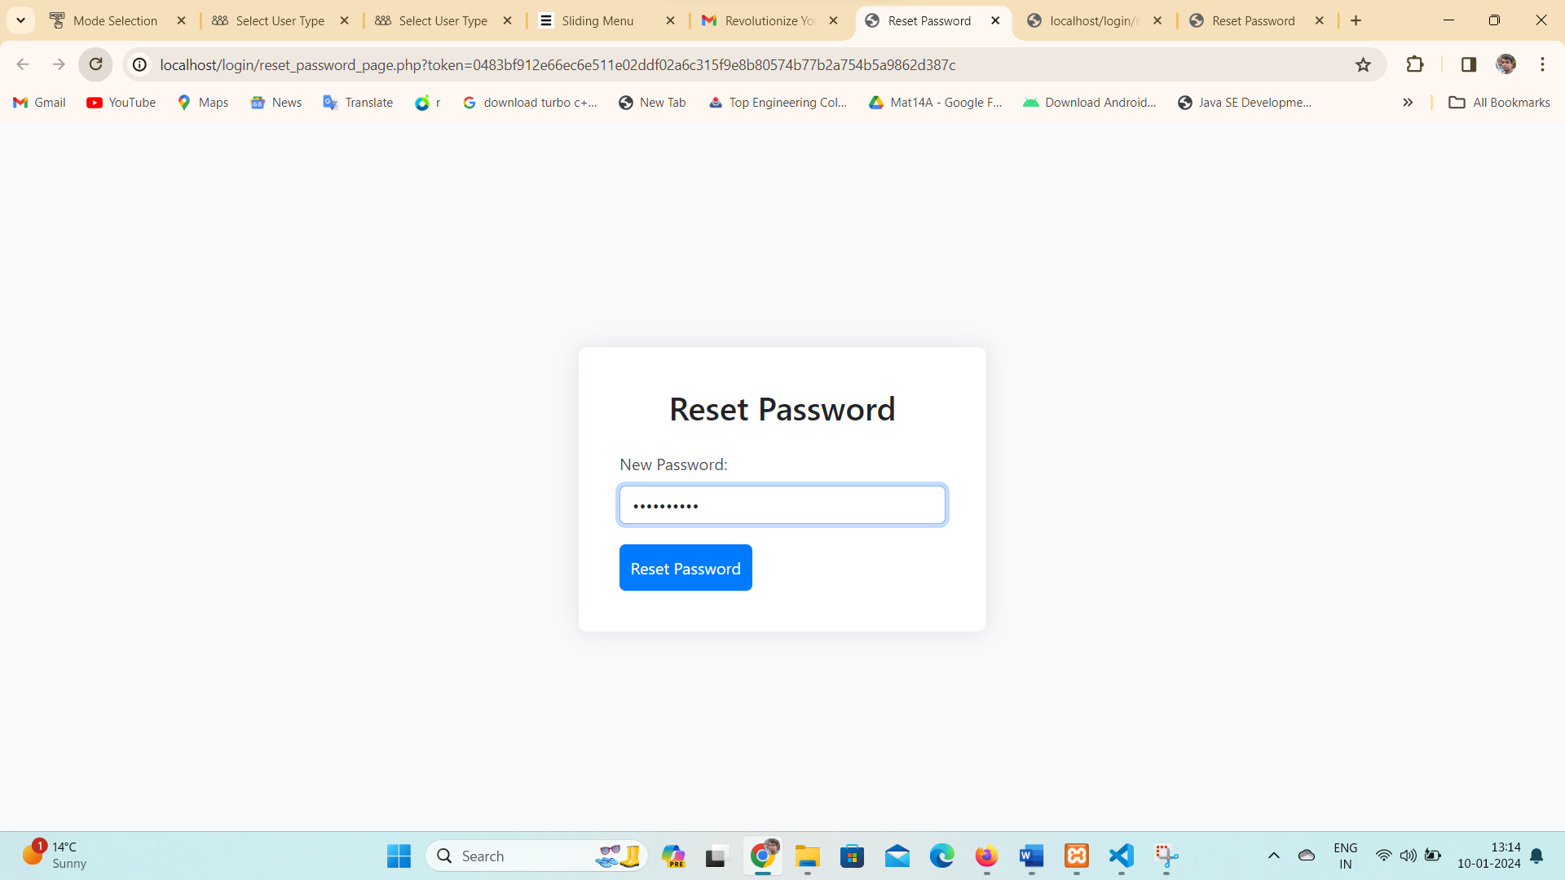

Figure 5.3 Reset Password

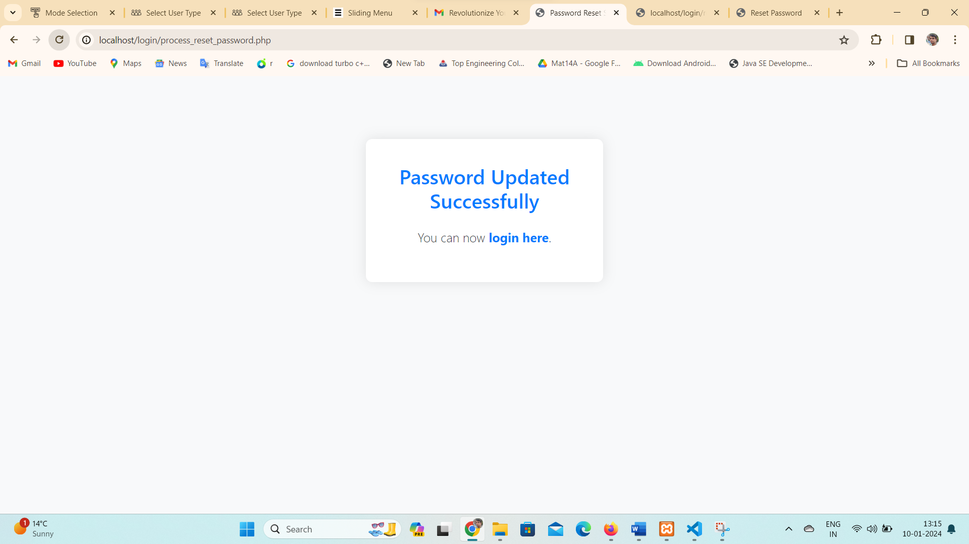

Figure 5.4 Password Updated Successfully



Figure 5.5 User Expense Dashboard

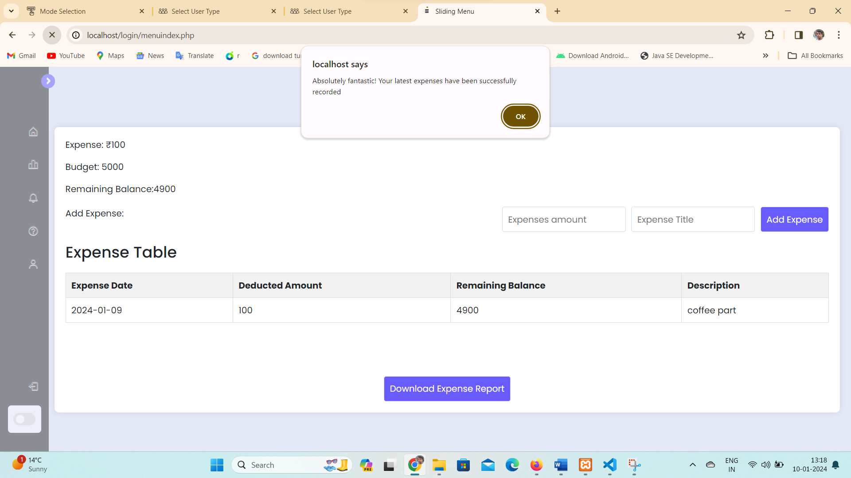

Figure 5.6 Adding expense alert.



Figure 5.7 New Expenses Added successfully.

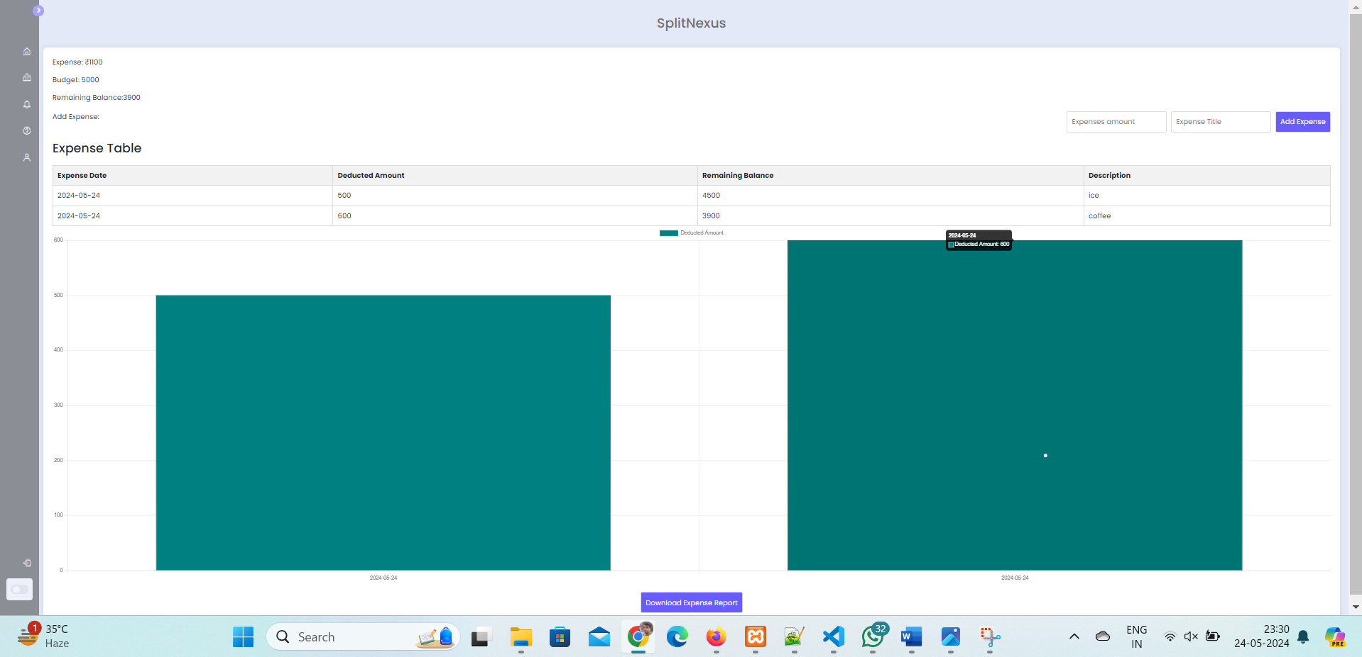

Figure 5.8 Graphical Expense Analysis

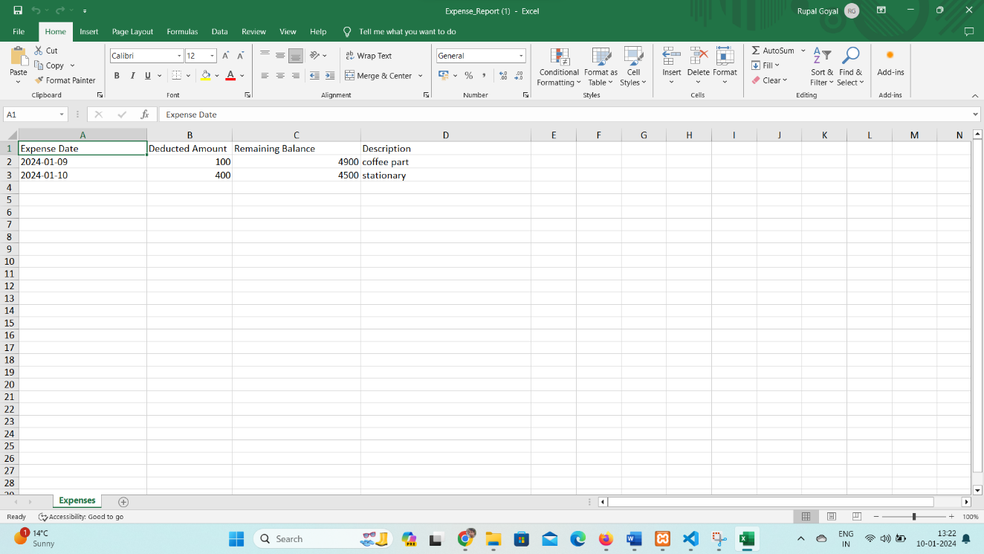

Figure 5.9 Expense Spreadsheets View

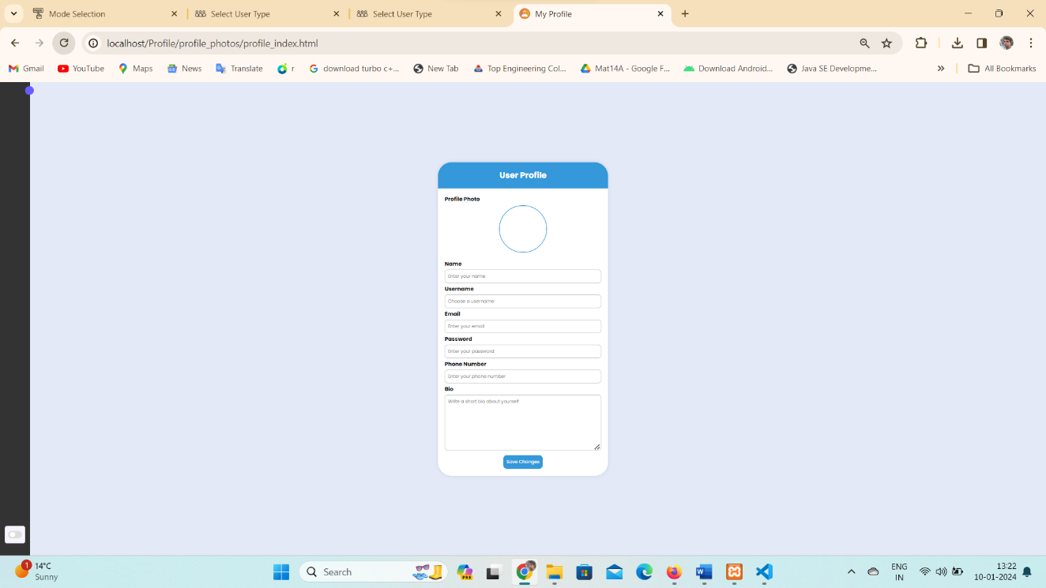

Figure 6.1 User Profile Page

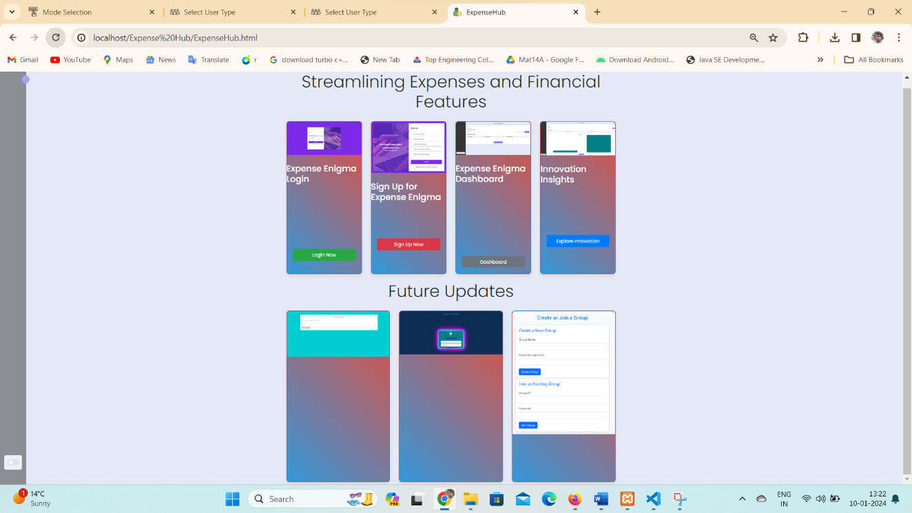

Figure 6.2 Financial Features

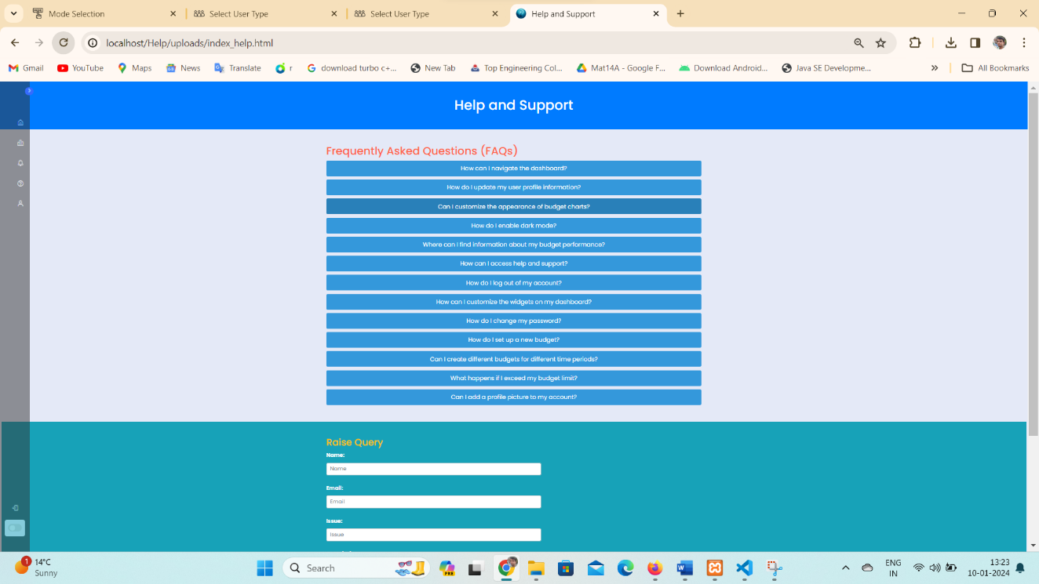

Figure 6.3 Help and Support Page



Figure 6.4 Raise Query Support

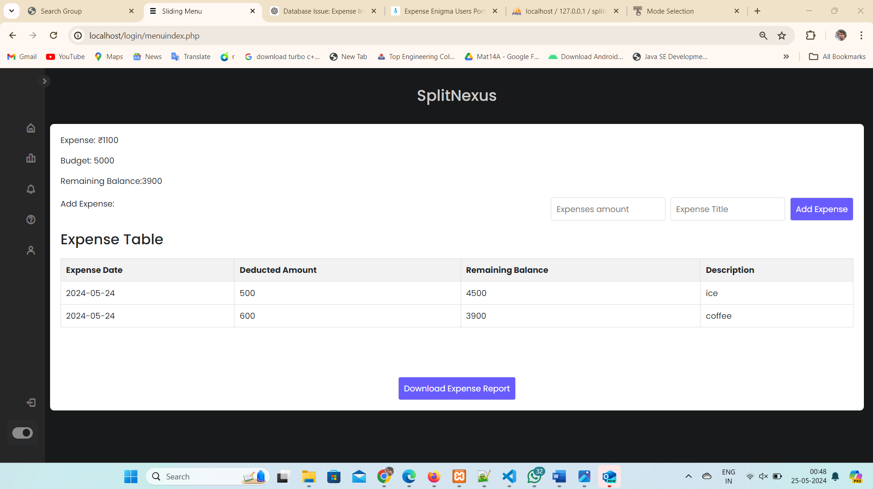

Figure 6.5 Dark Mode Enabled Feature

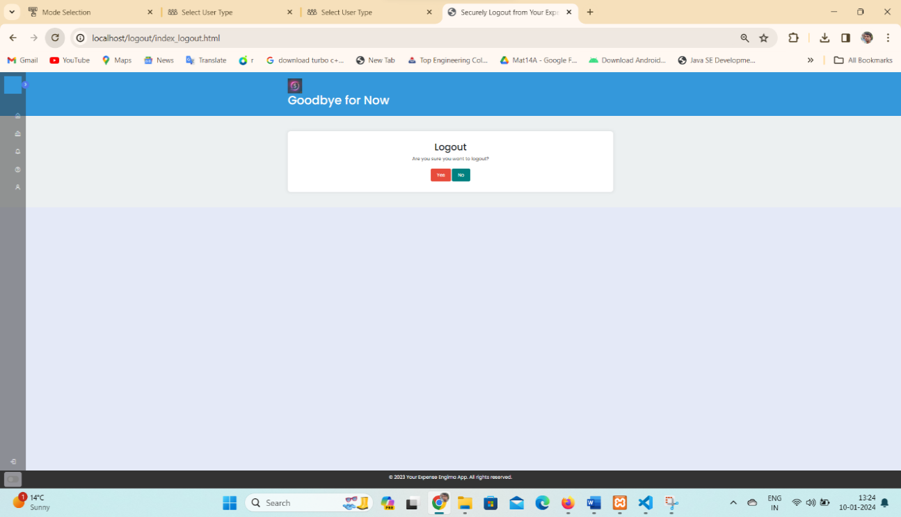

Figure 6.6 Logout Split Nexus Services

**4.1.8 Guest User Mode (Explore Mode):**

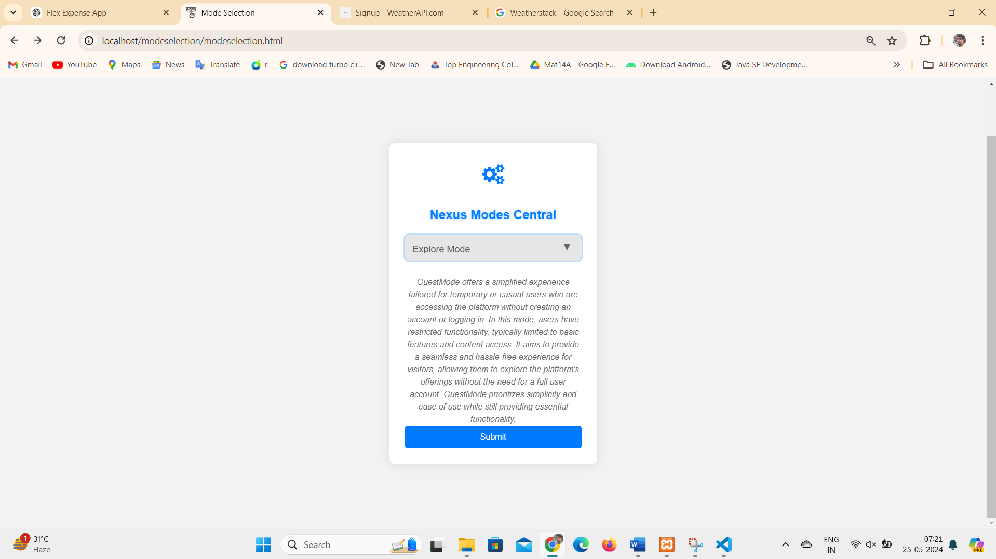

Figure 6.7 Guest (Explorer Mode) Split Nexus Services

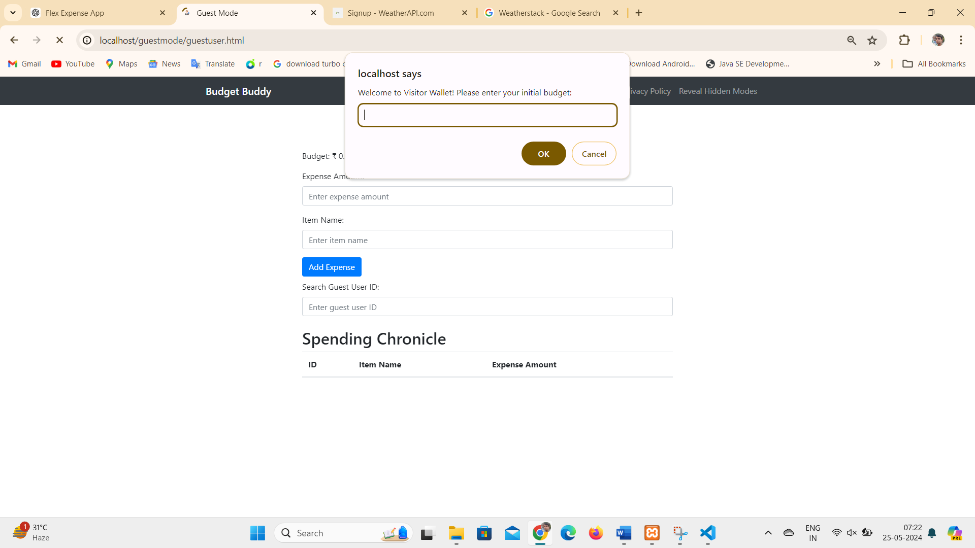

Figure 6.8 Guest User Prompt for Initial Budget

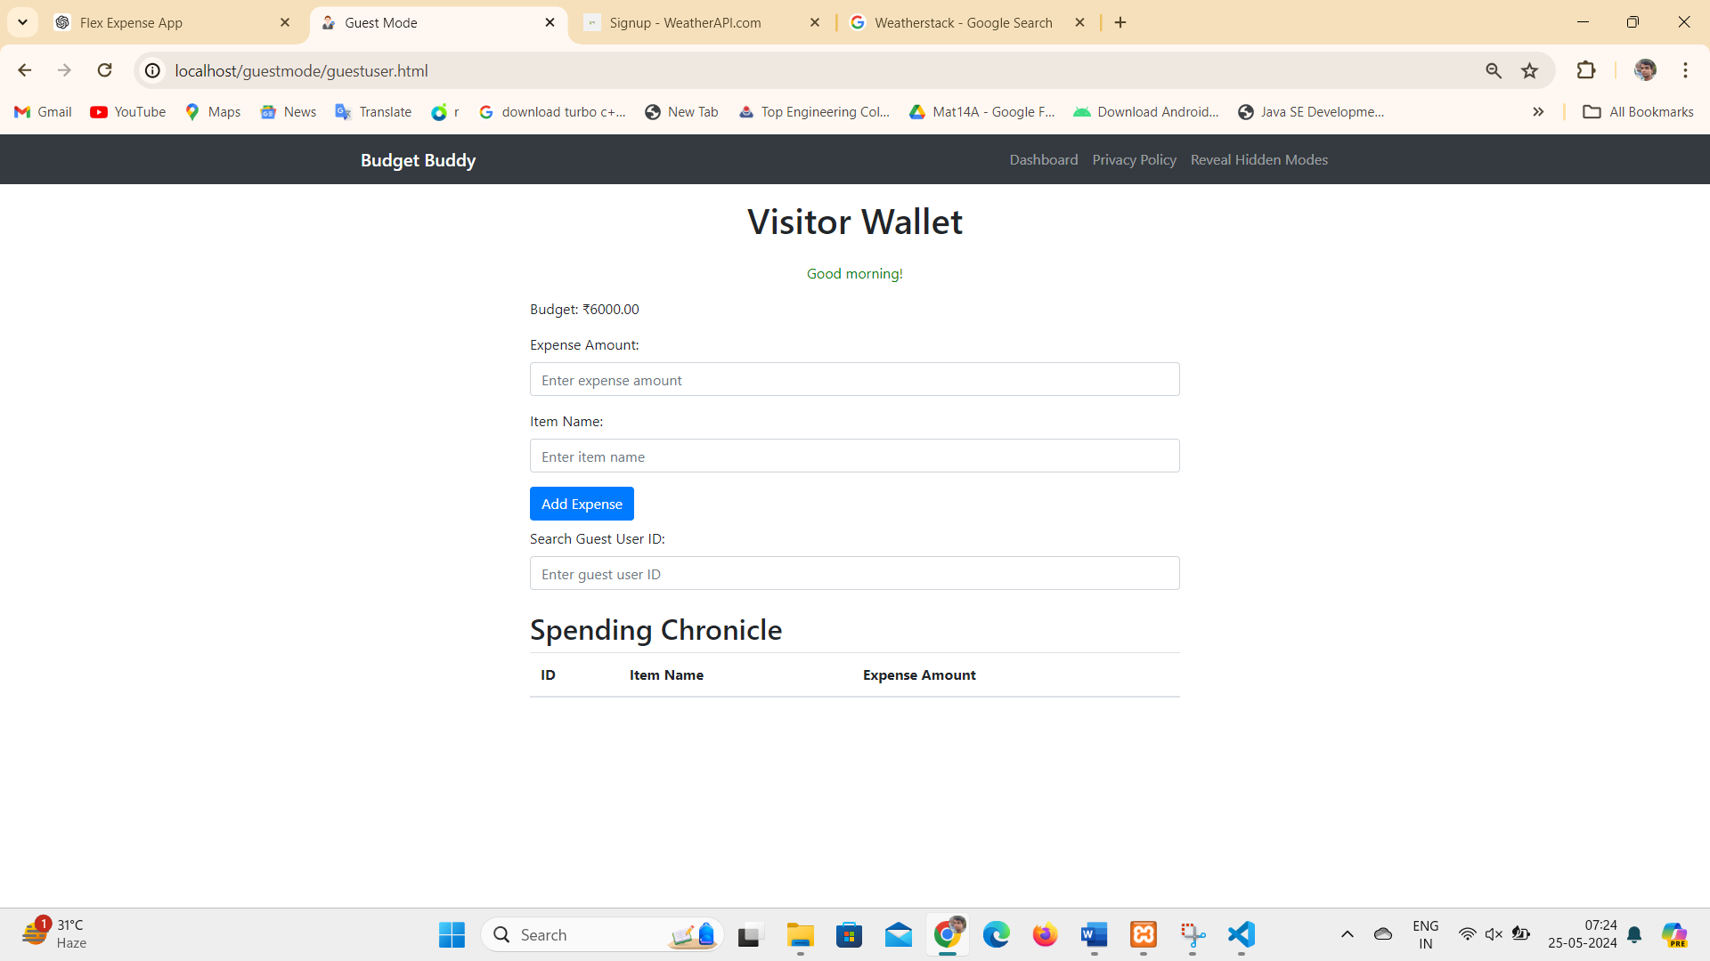

Figure 6.9 Guest User Budget

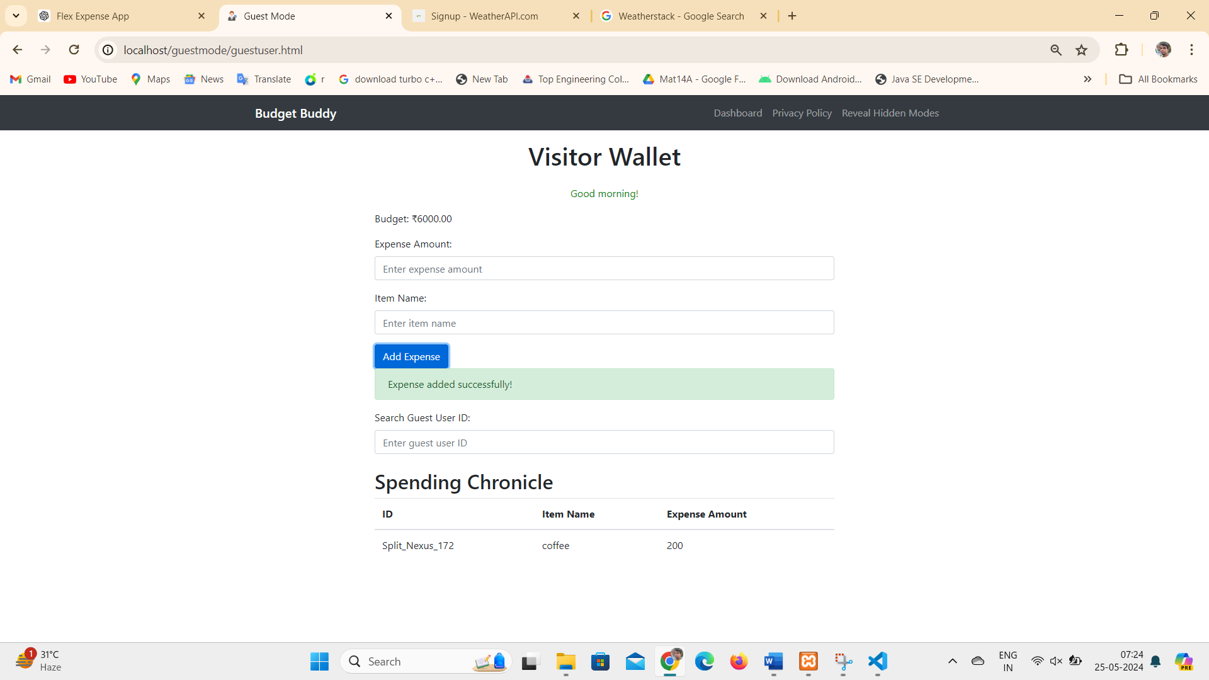

Figure 7.1 Guest User Expenses

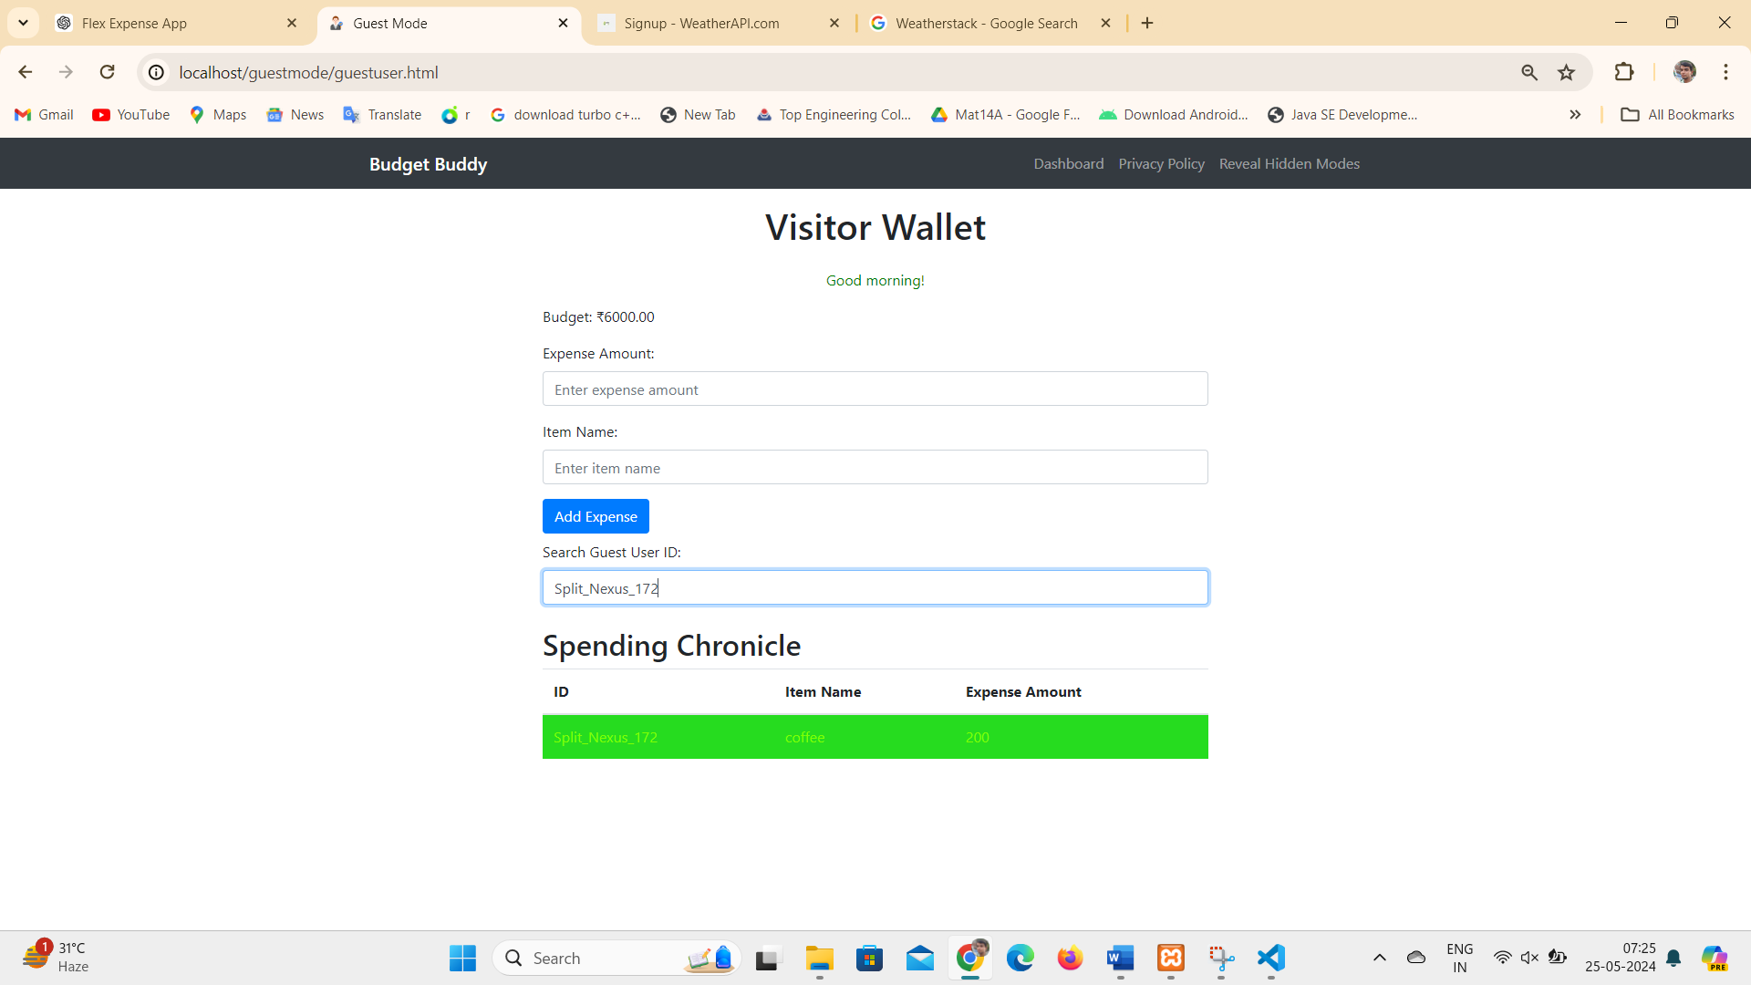

Figure 7.2 Search Guest User Spending by Unique Guest user id

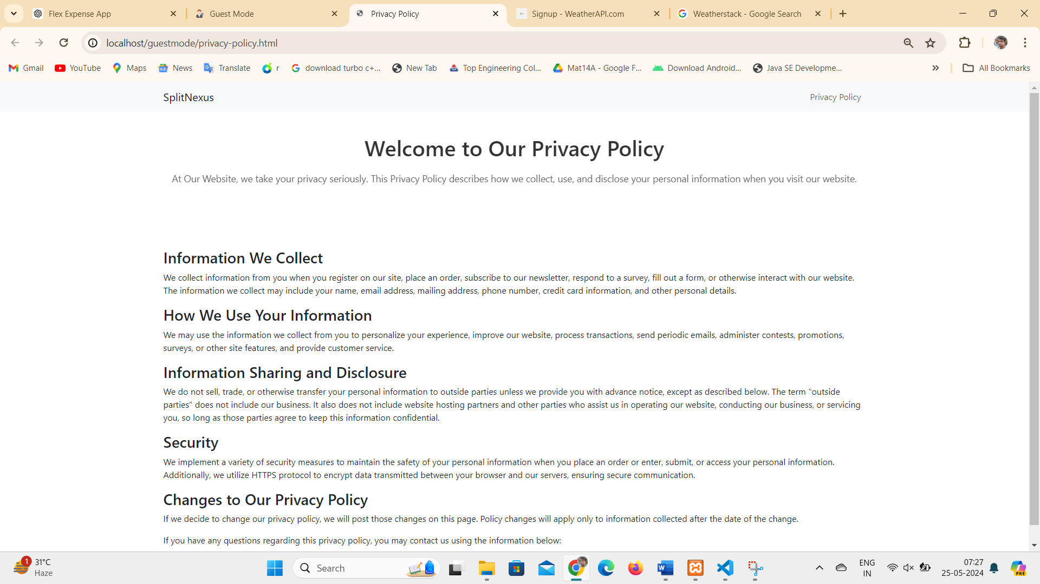

Figure 7.3 Privacy Policy for Guest user

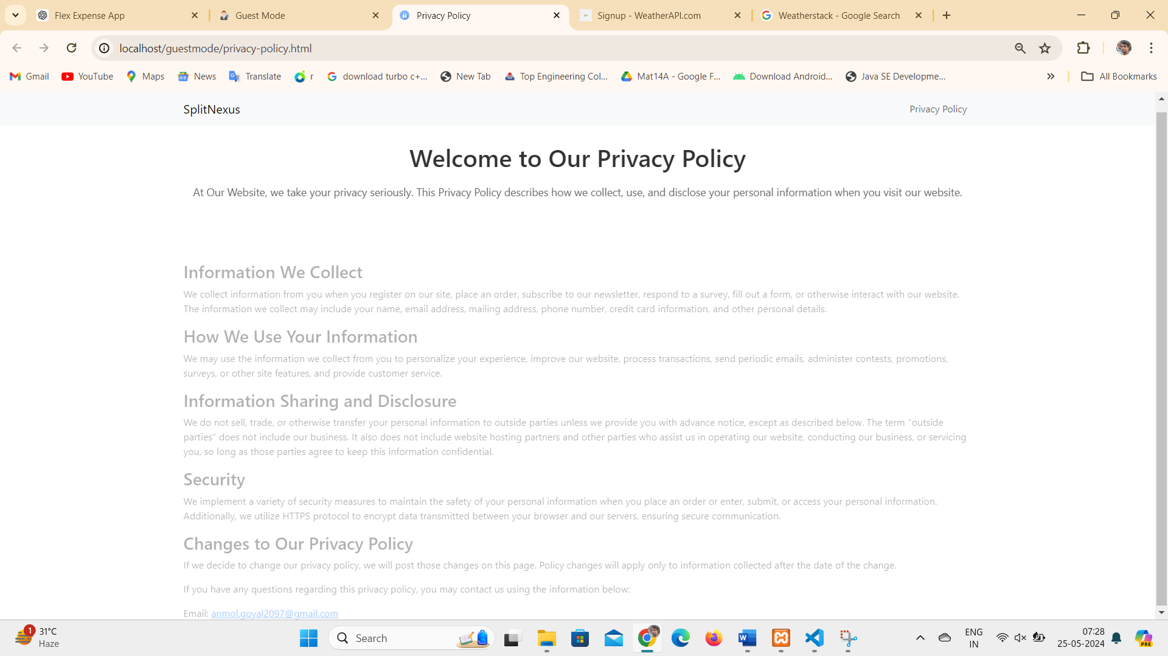

Figure 7.4 Guest user Question mail to email id

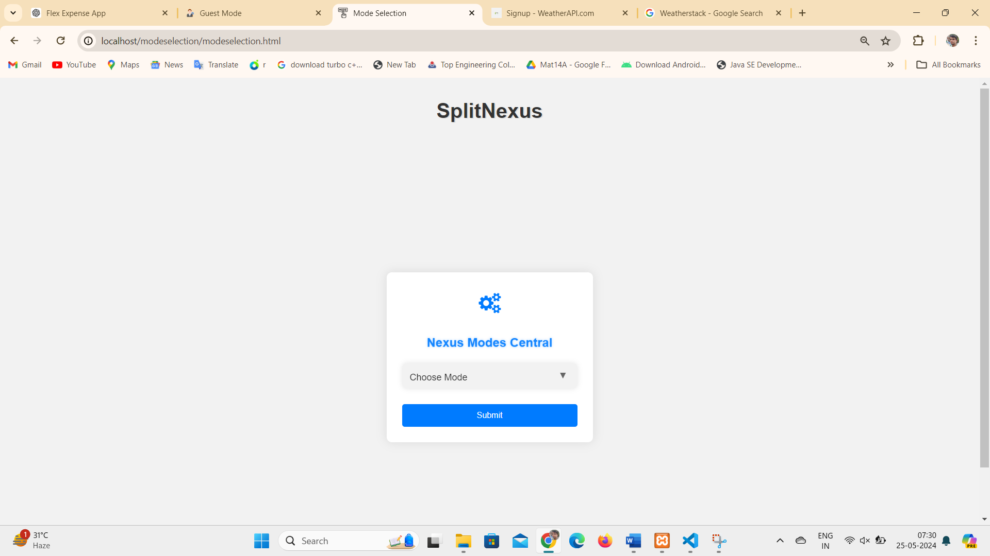

Figure 7.5 Guest user unlocks 'Reveal Hidden Mode' for expanded features.

**4.1.8 Report Mode:**

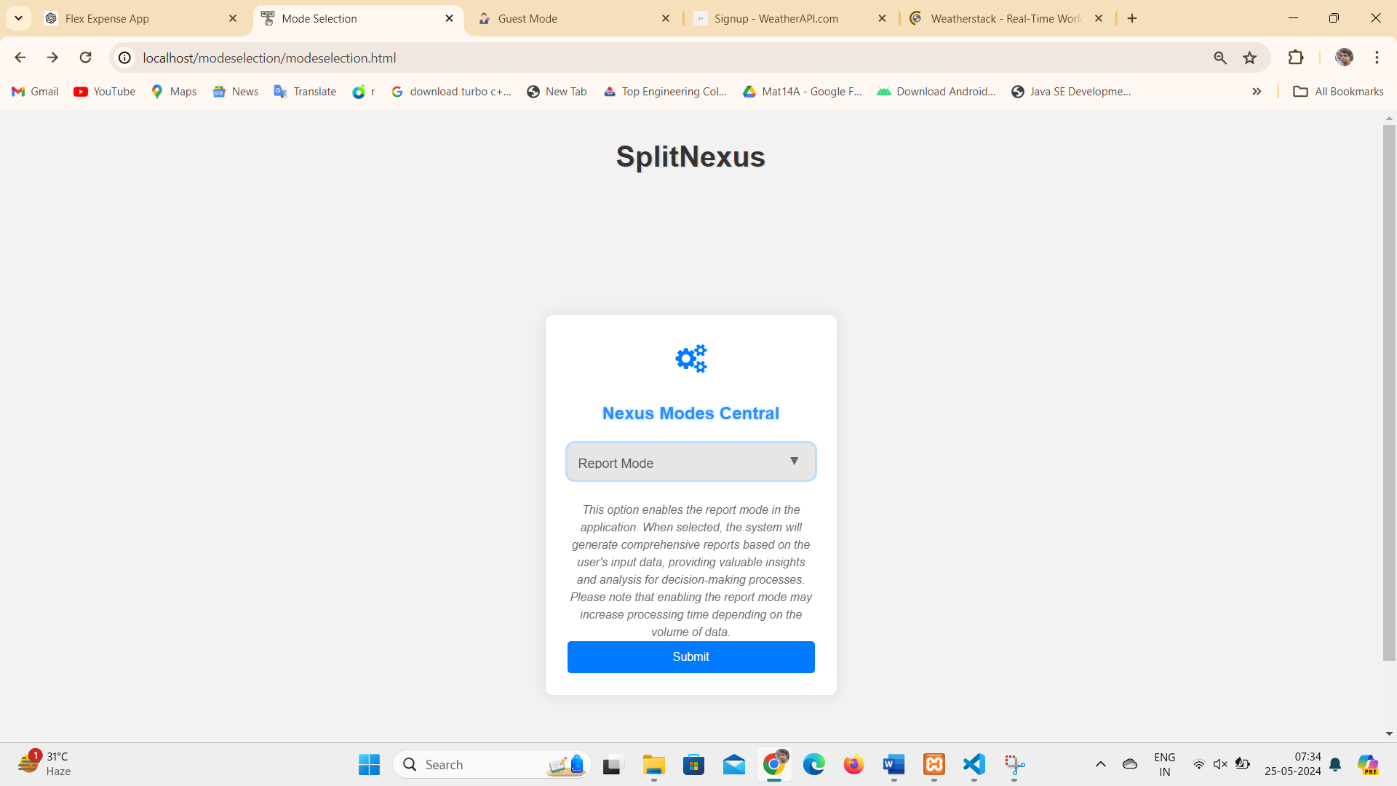

Figure 7.6 Report Mode for User expenses

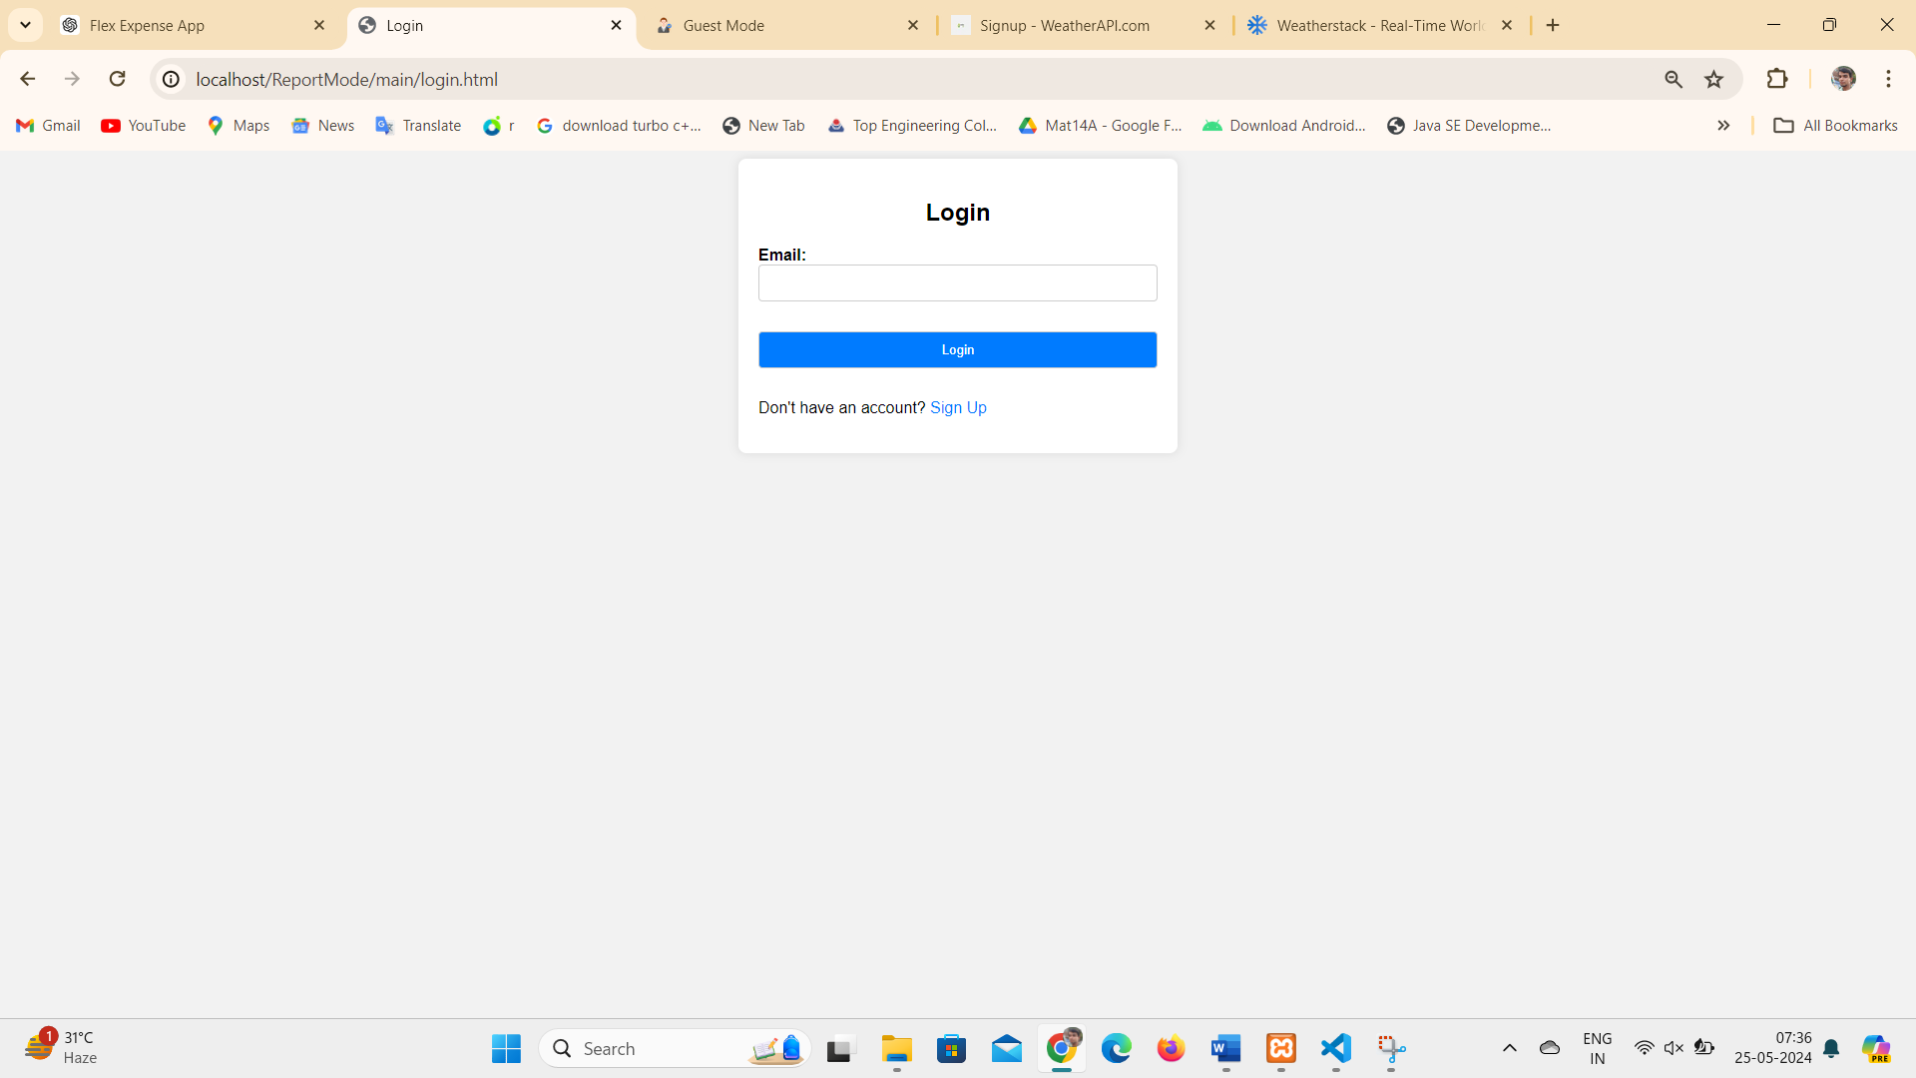

Figure 7.7 User login for Reports

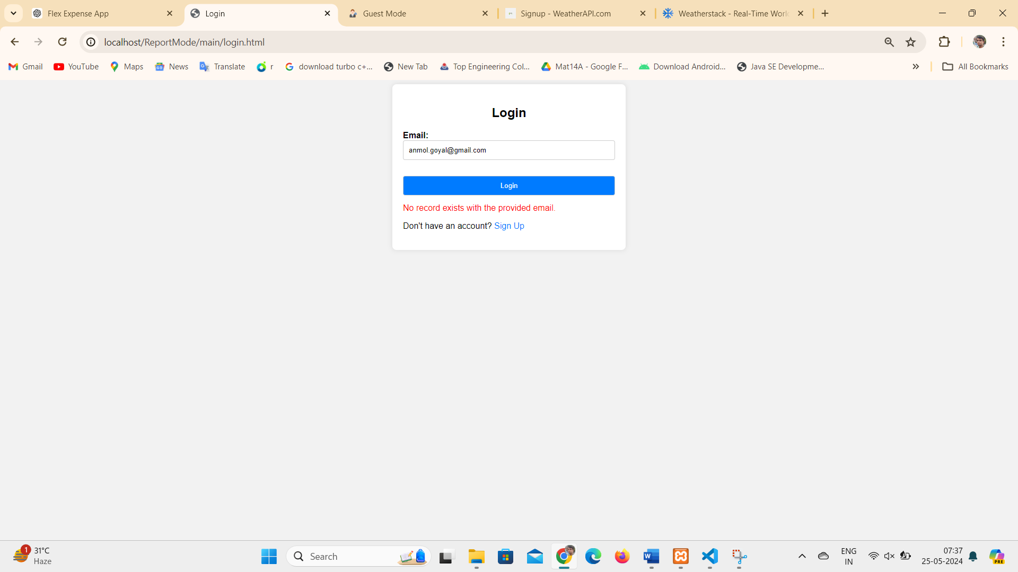

Figure 7.8 User invalid email Error (if user does not enter registered mail)

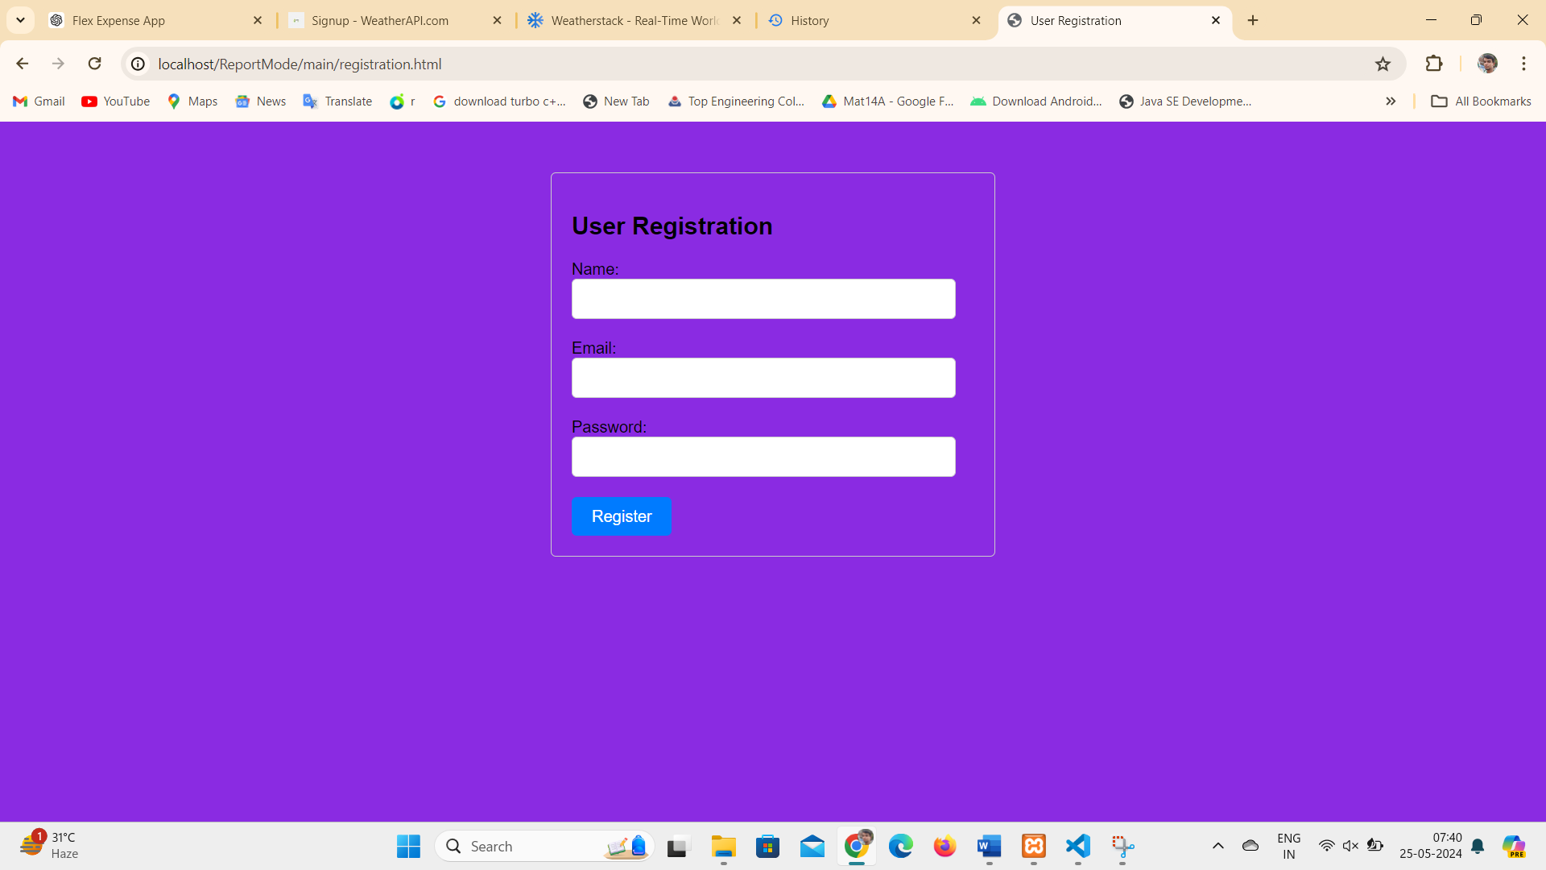

Figure 7.9 Registration upon matching user details with login criteria

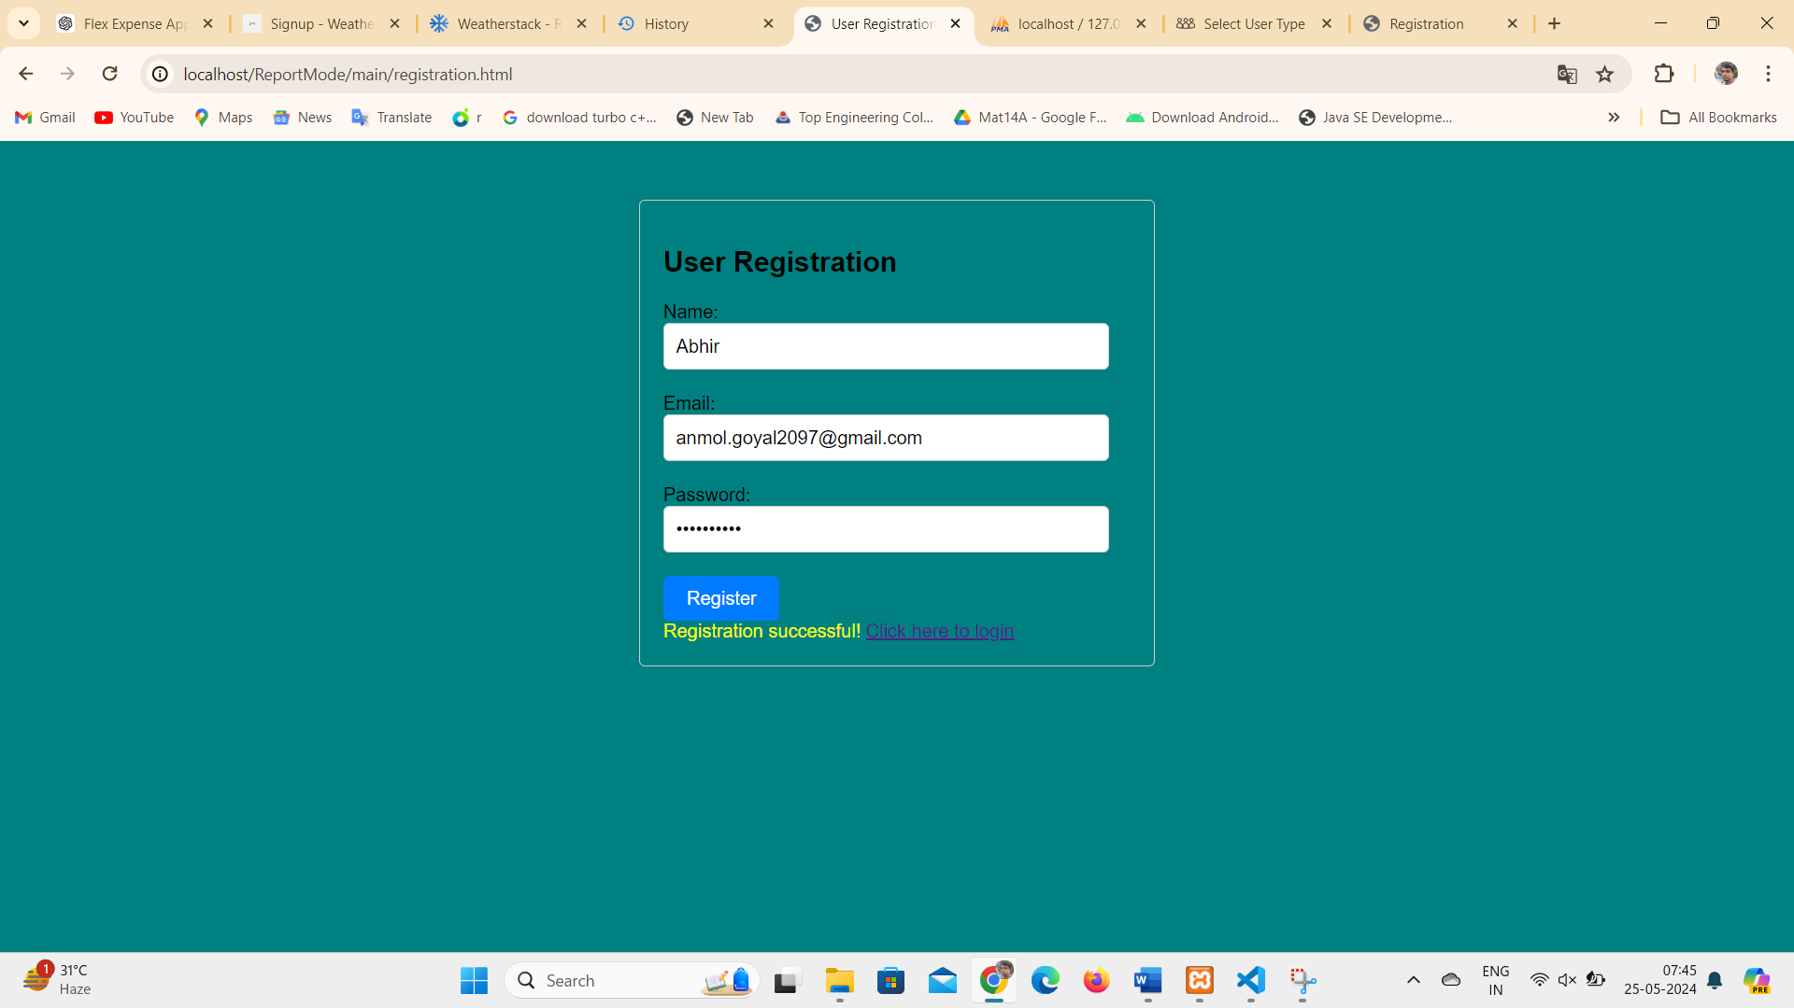

Figure 8.1 User details matched (Registration Successfully Done)

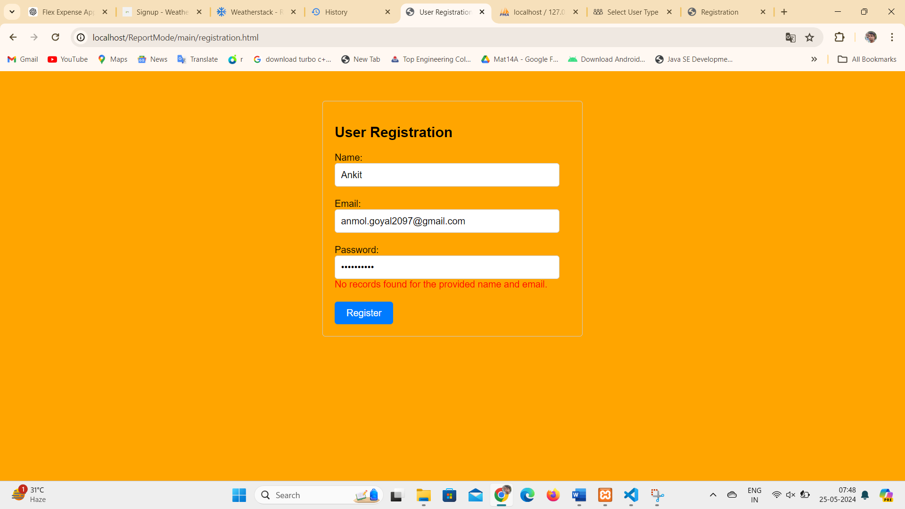

Figure 8.2 User Enter Wrong details matched (No record Found)

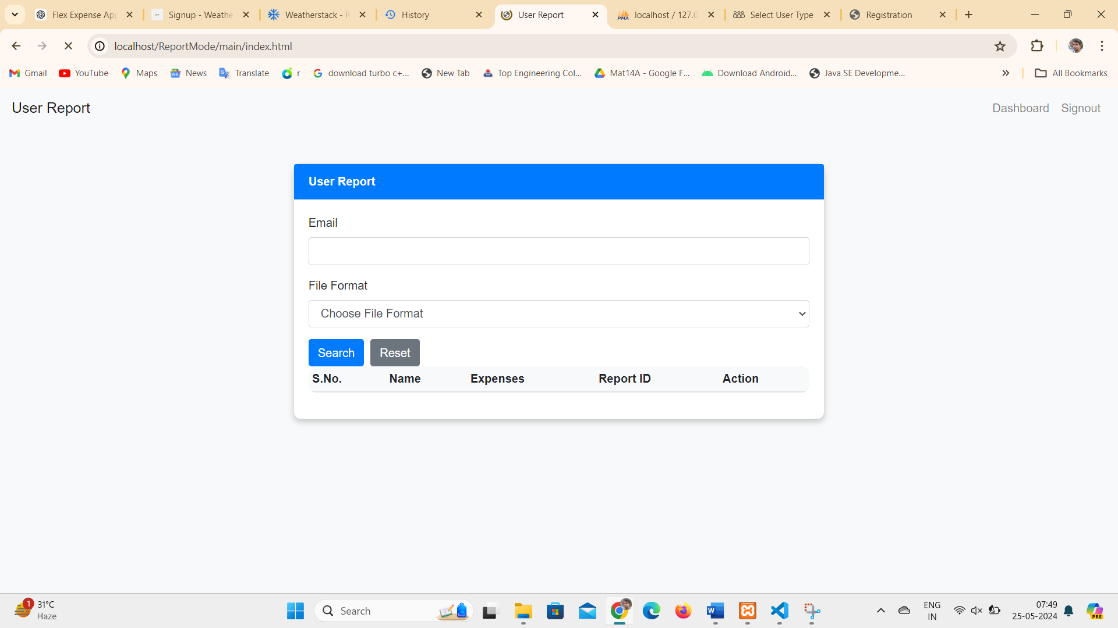

Figure 8.3 Registered User Dashboard

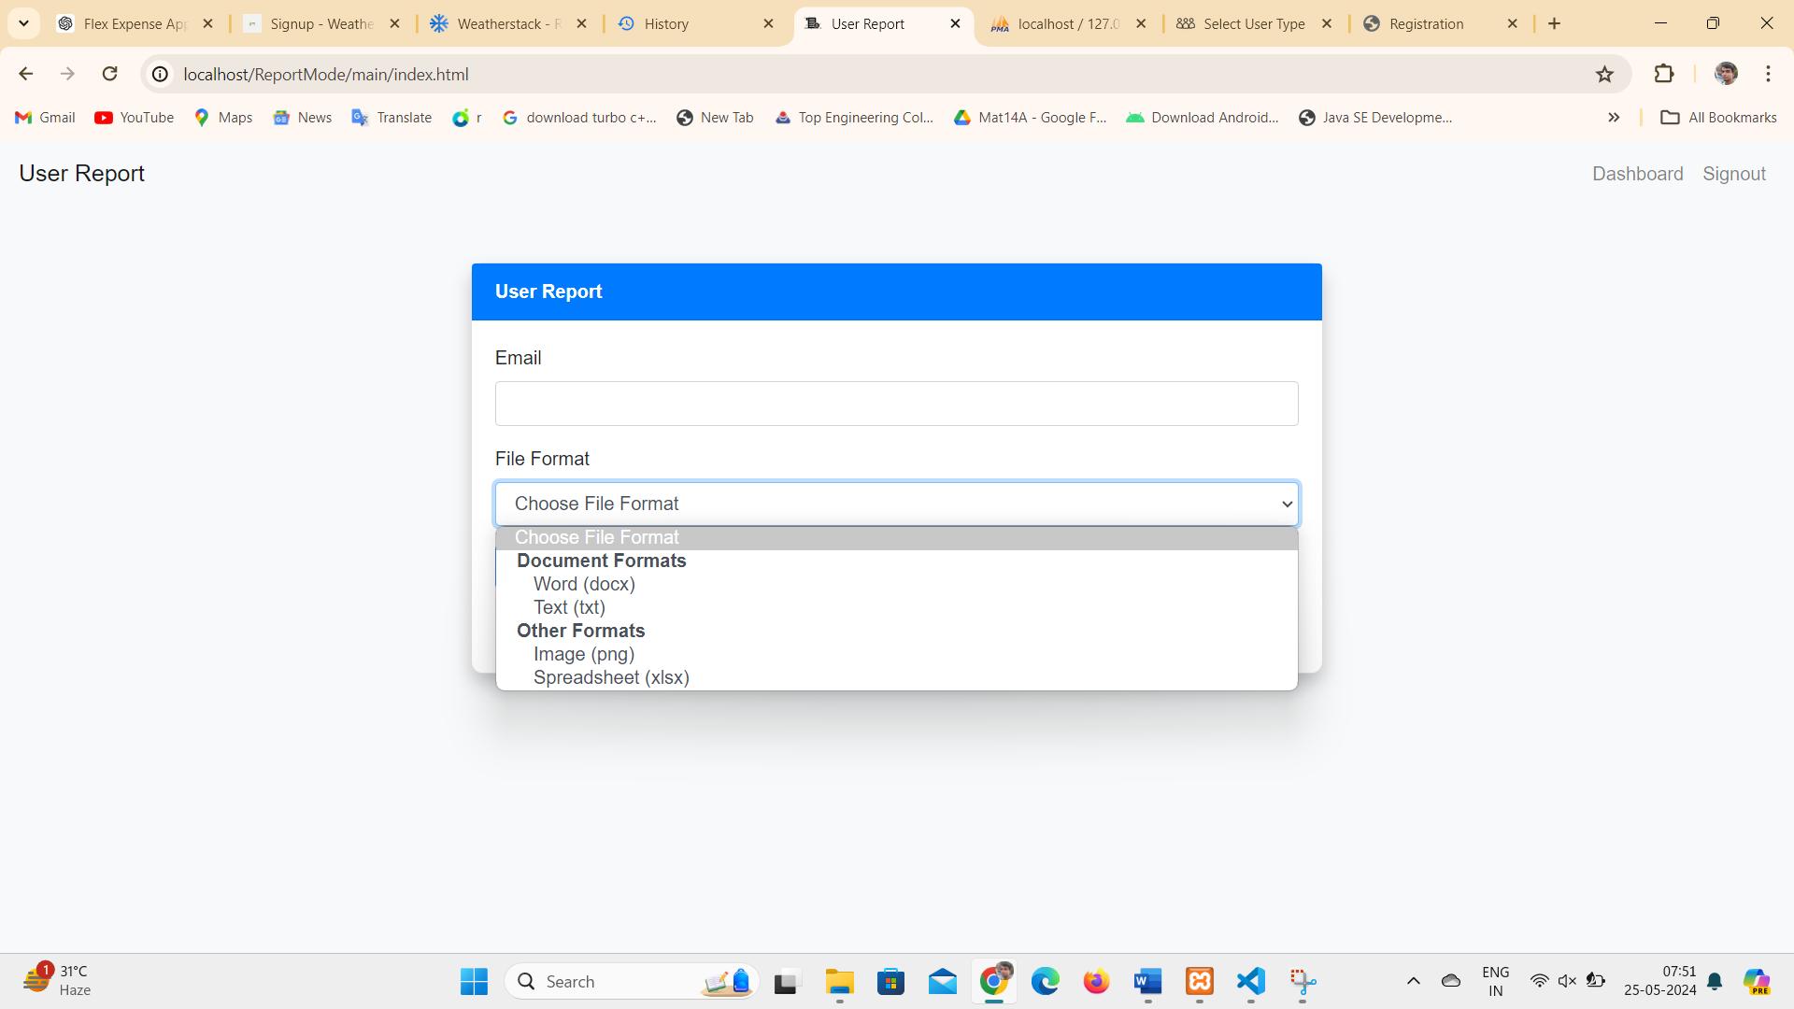

Figure 8.4 File Format for Reports

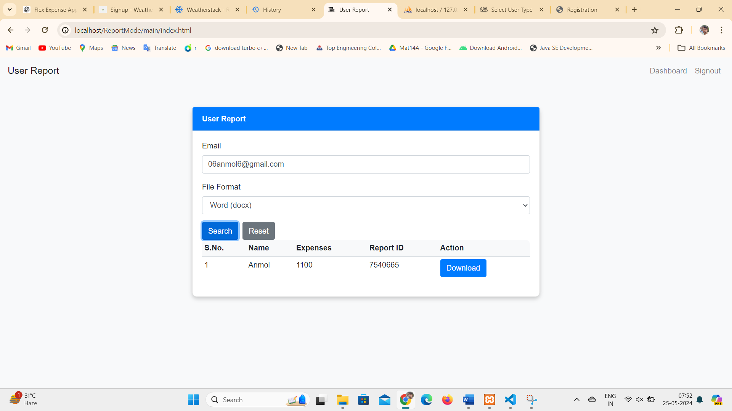

Figure 8.5 User Word Format Report

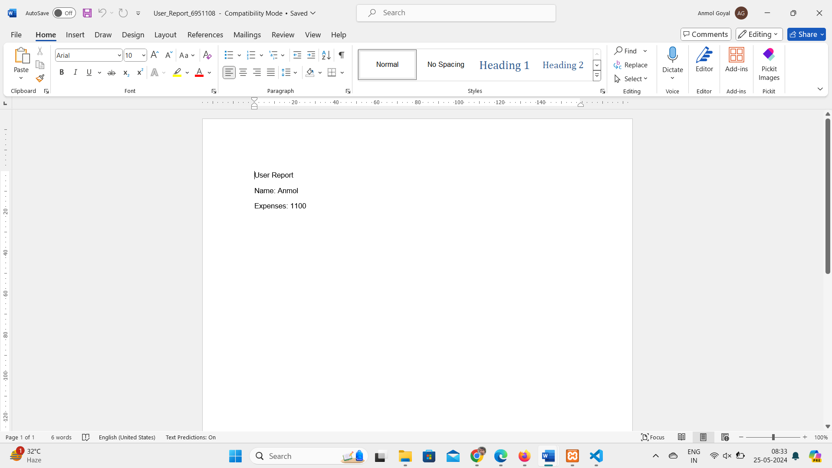

Figure 8.6 Report Word Format

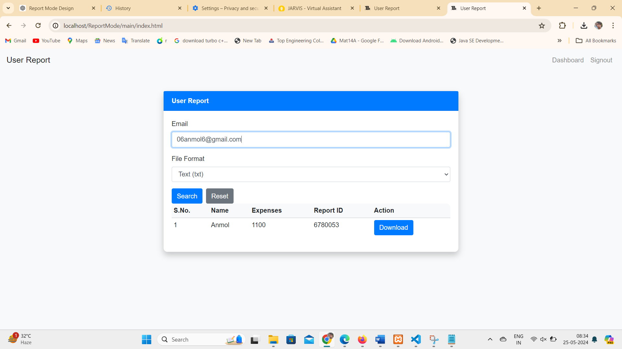

Figure 8.7 User Report Text Format

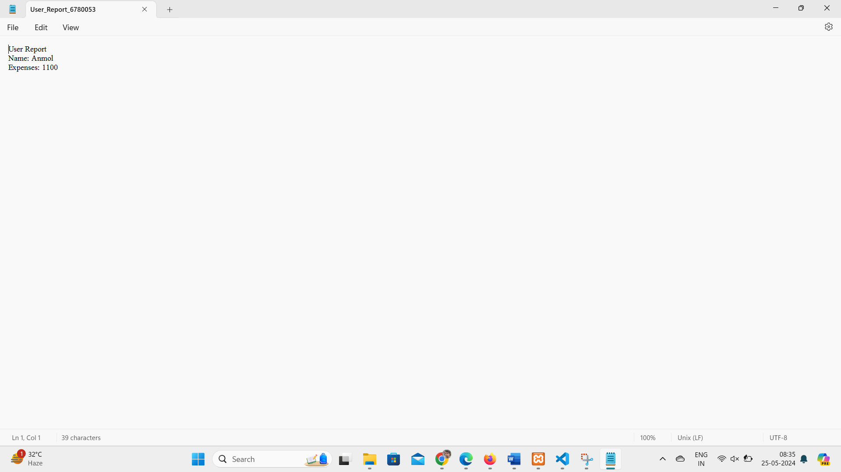

Figure 8.8 Report Text Format

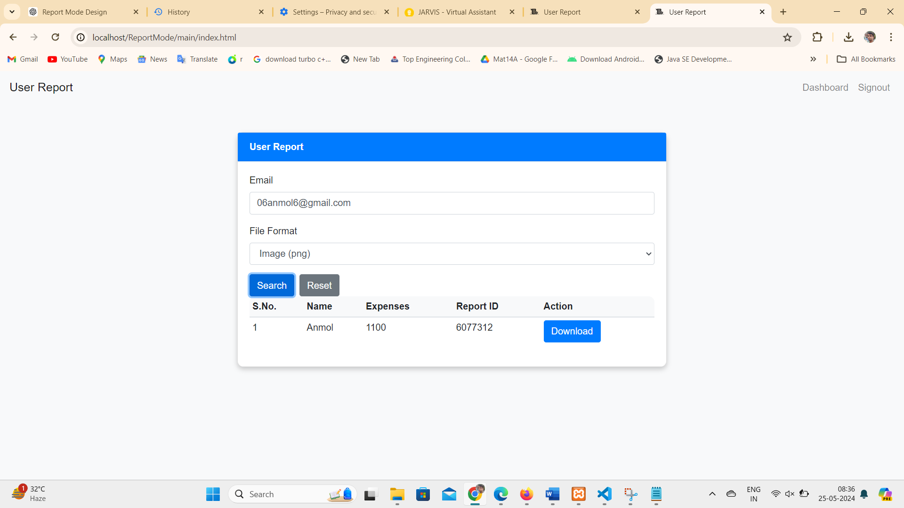

Figure 8.9 User Report Image Format



Figure 9.1 Image Report Format

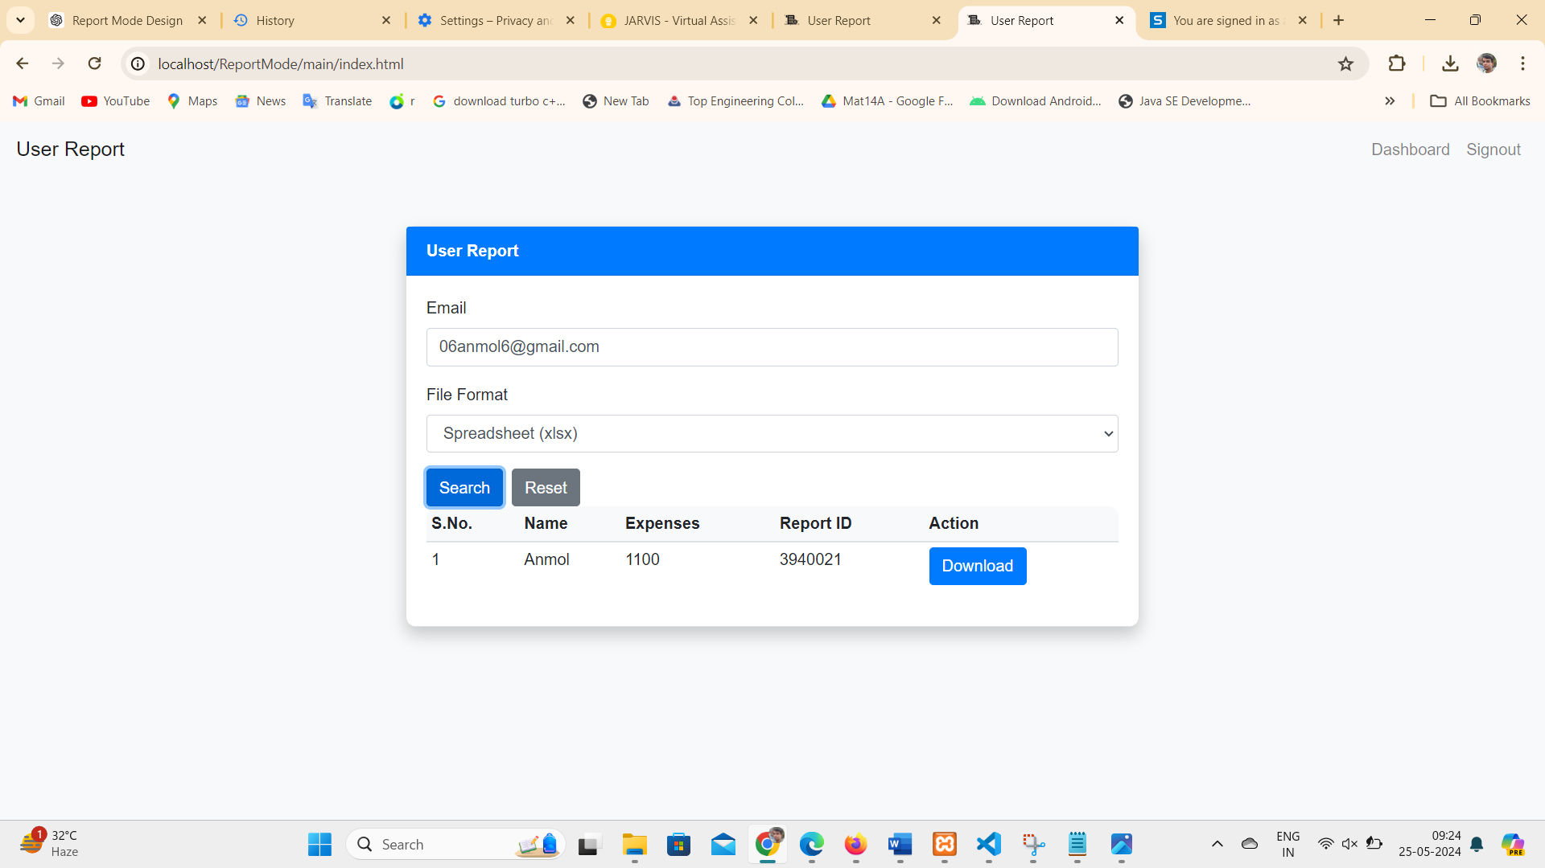

Figure 9.2 User Report Spreadsheet Format

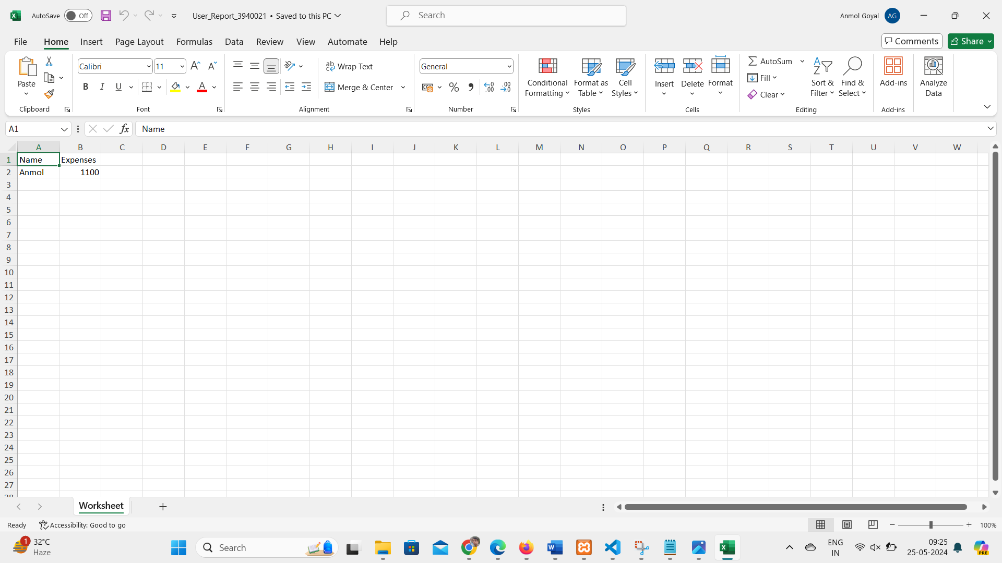

Figure 9.3 Spreadsheet Report Format



Figure 9.4 User Request for Logout permission

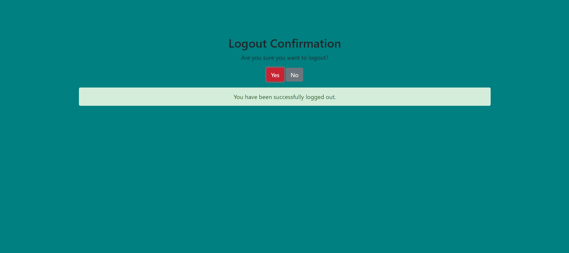

Figure 9.5 Successfully Logout

**4.1.9 Entertainment Mode:**

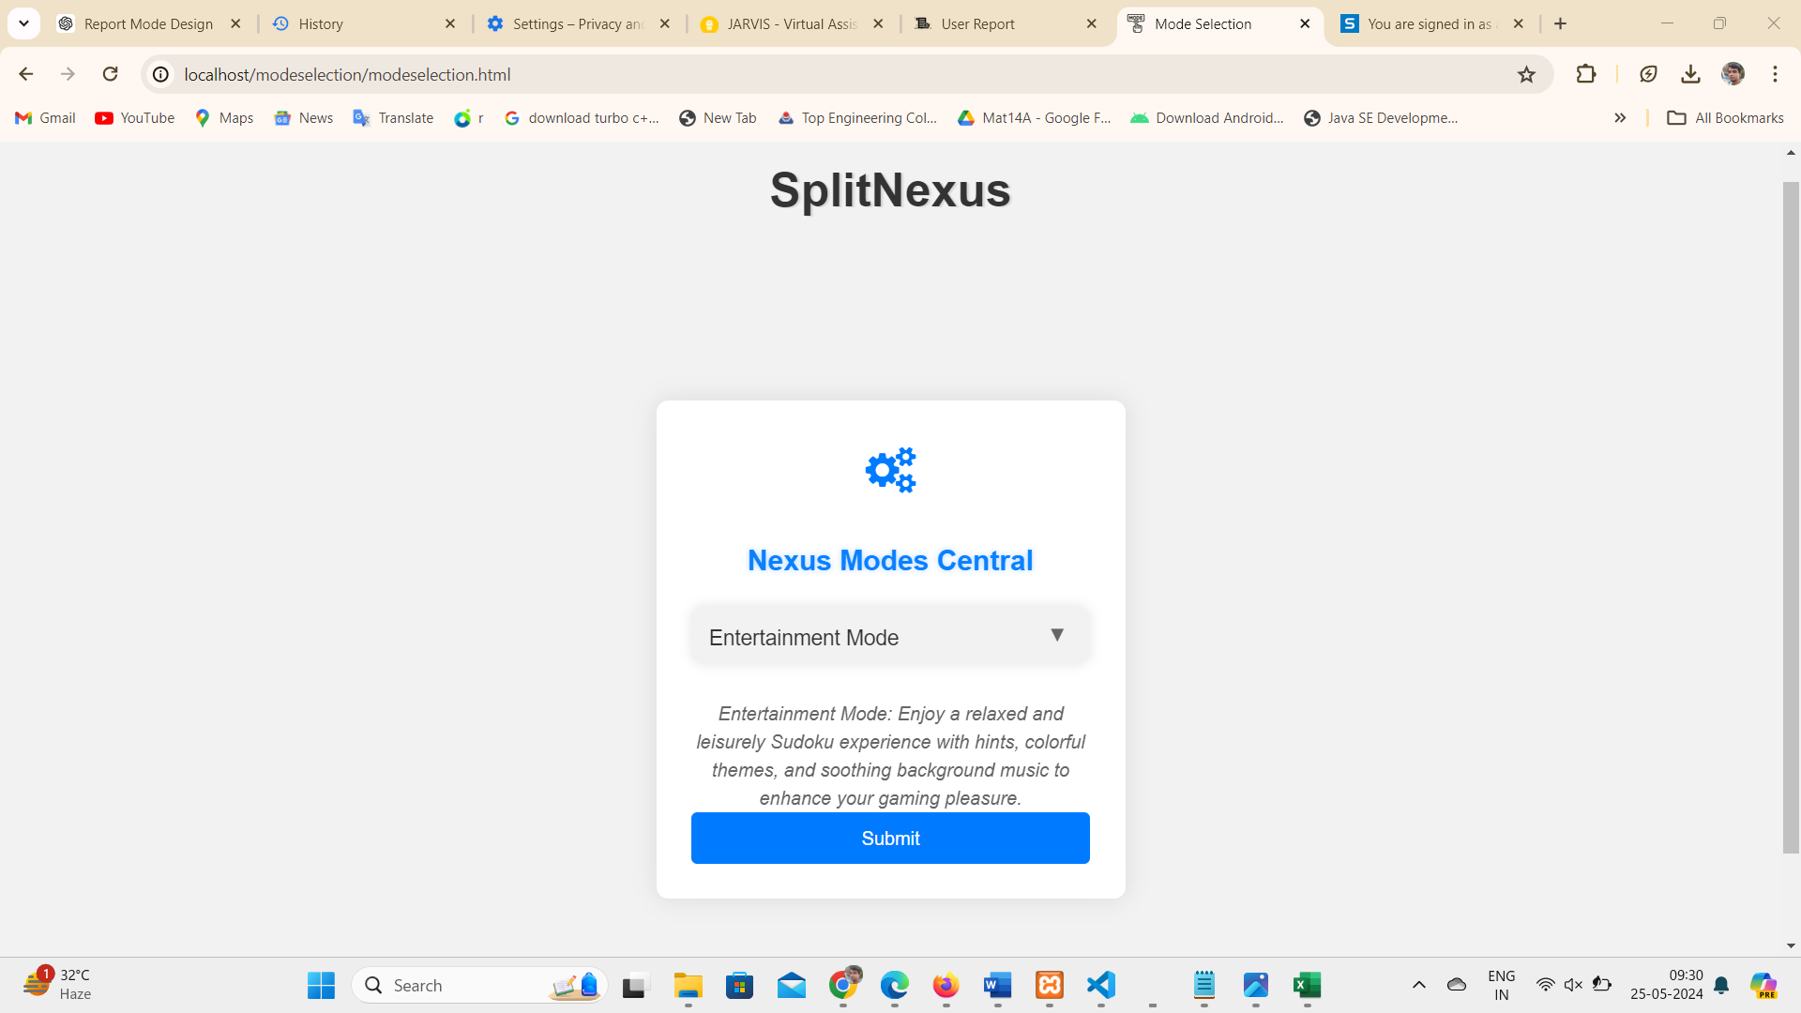

Figure 9.6 Entertainment Mode

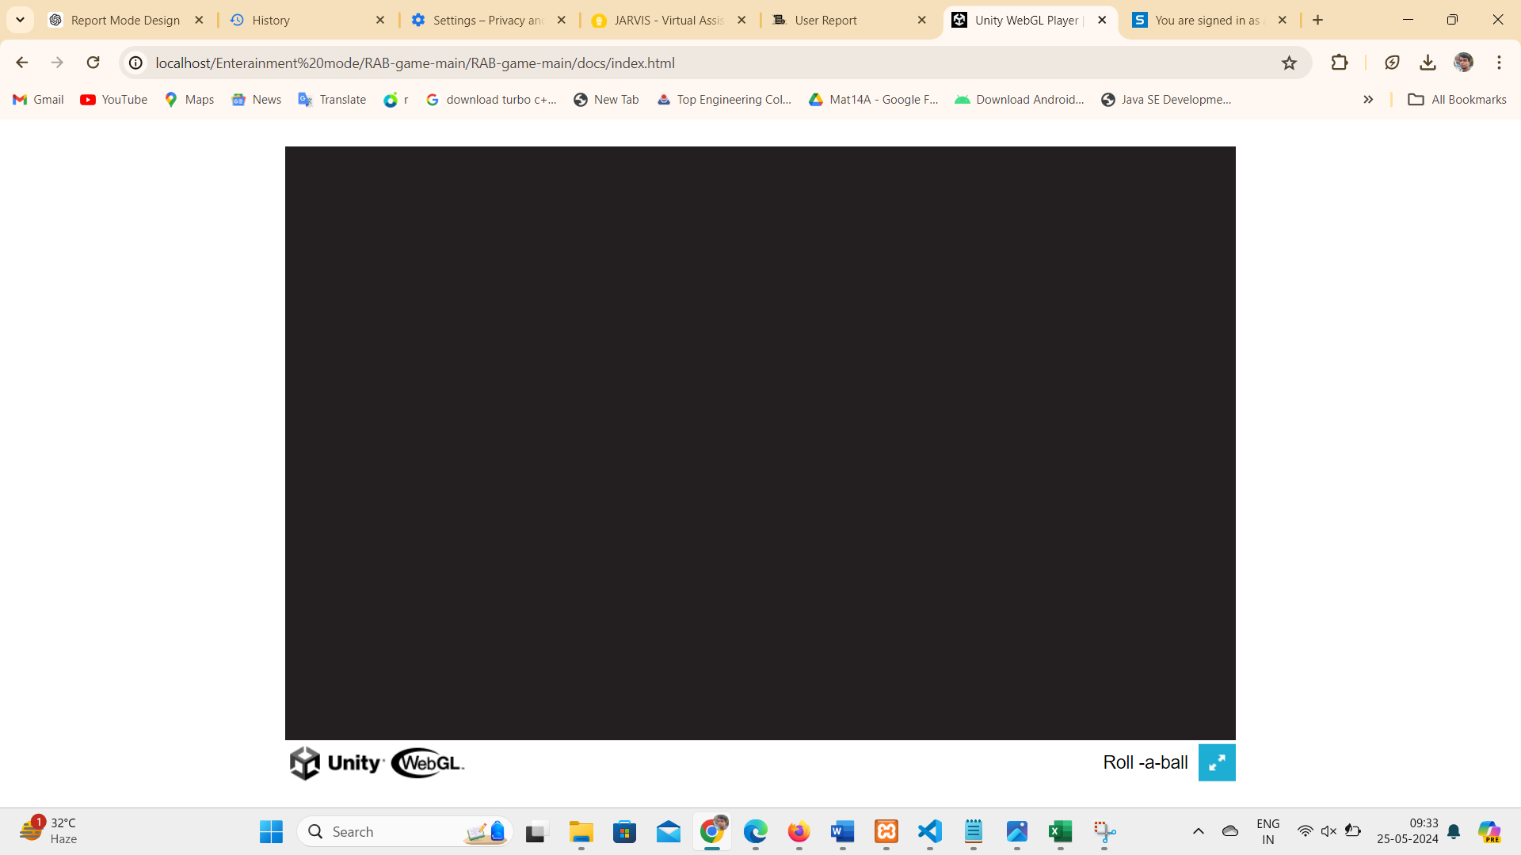

Figure 9.7 Entertainment Mode started.

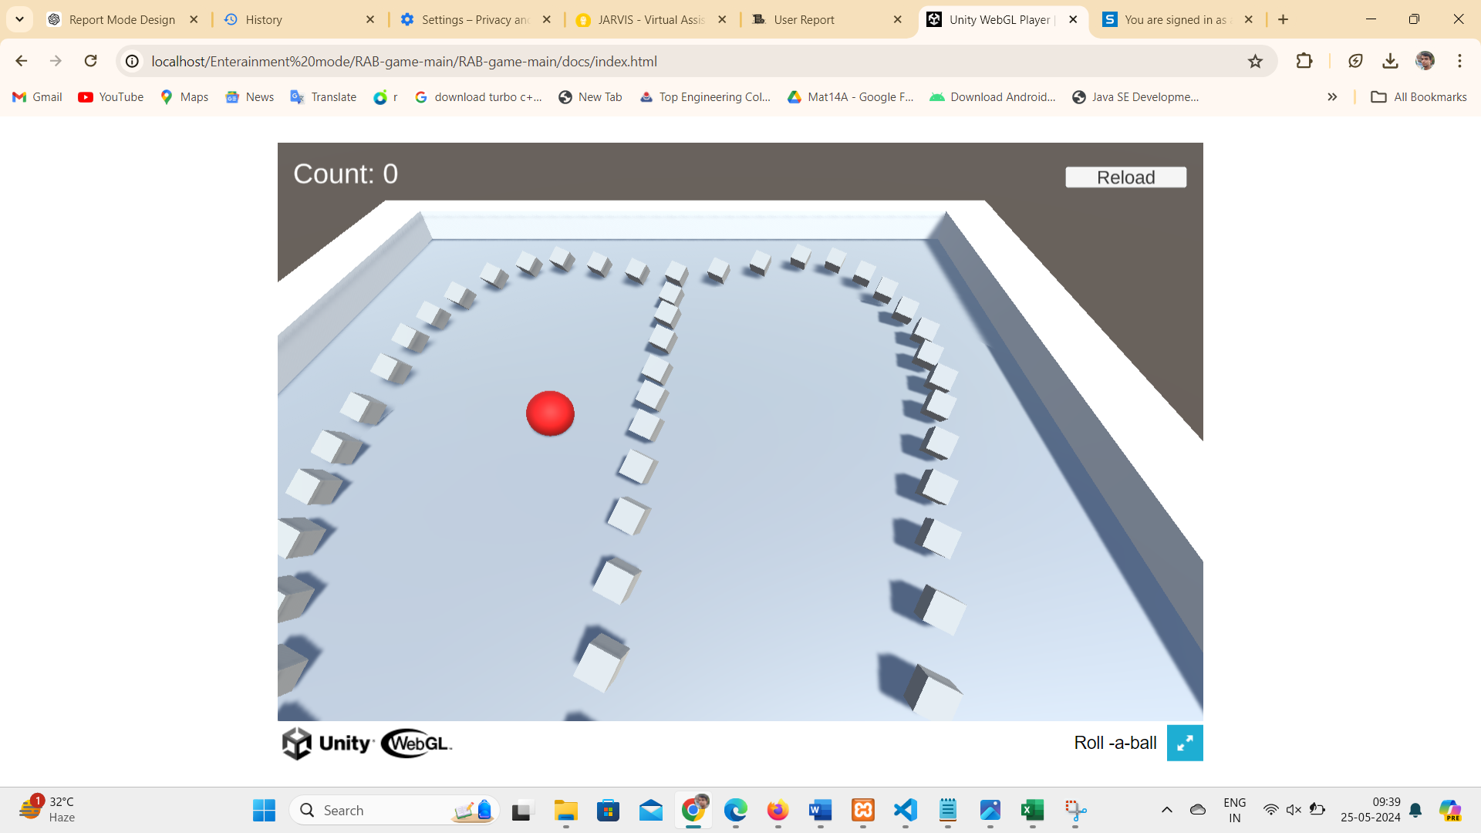

Figure 9.8 Game play mode

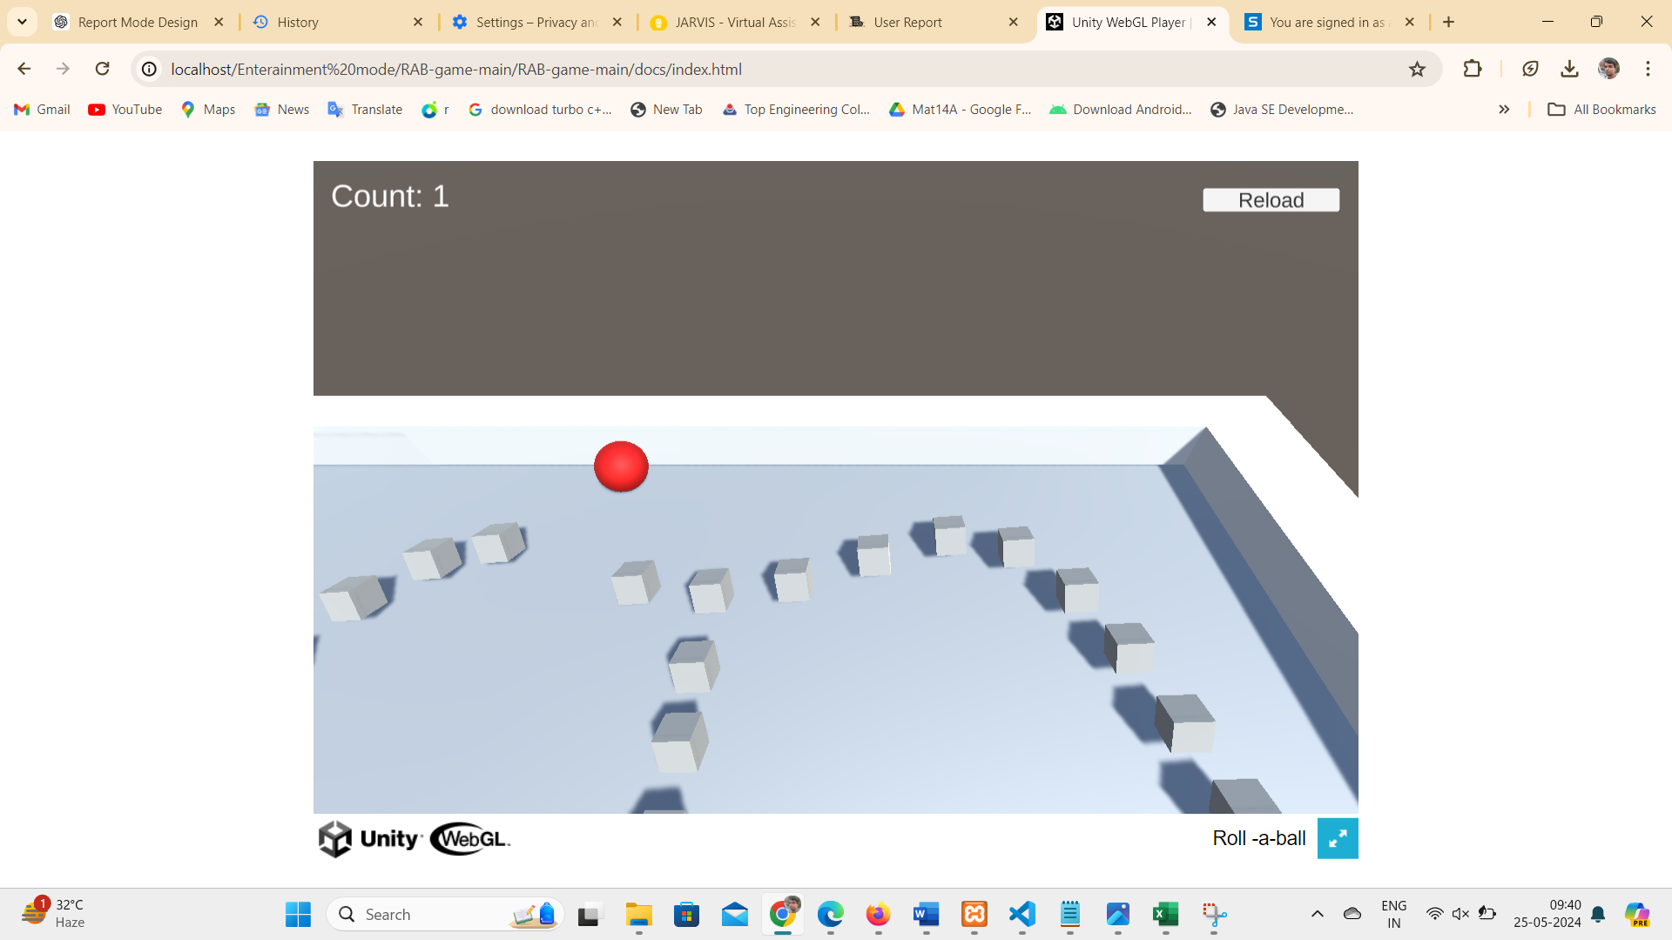

Figure 9.9 Count Point Started

**4.2.0 Whisper Wizard Mode:**

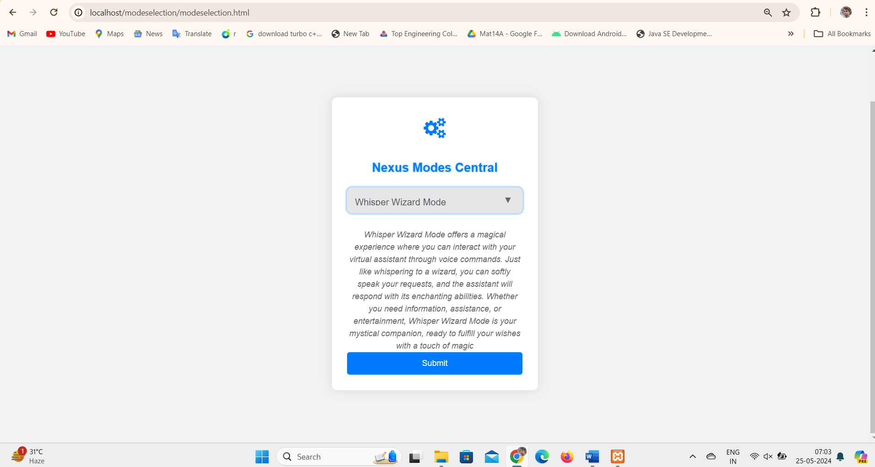

Figure 10.1 Whisper Wizard Mode

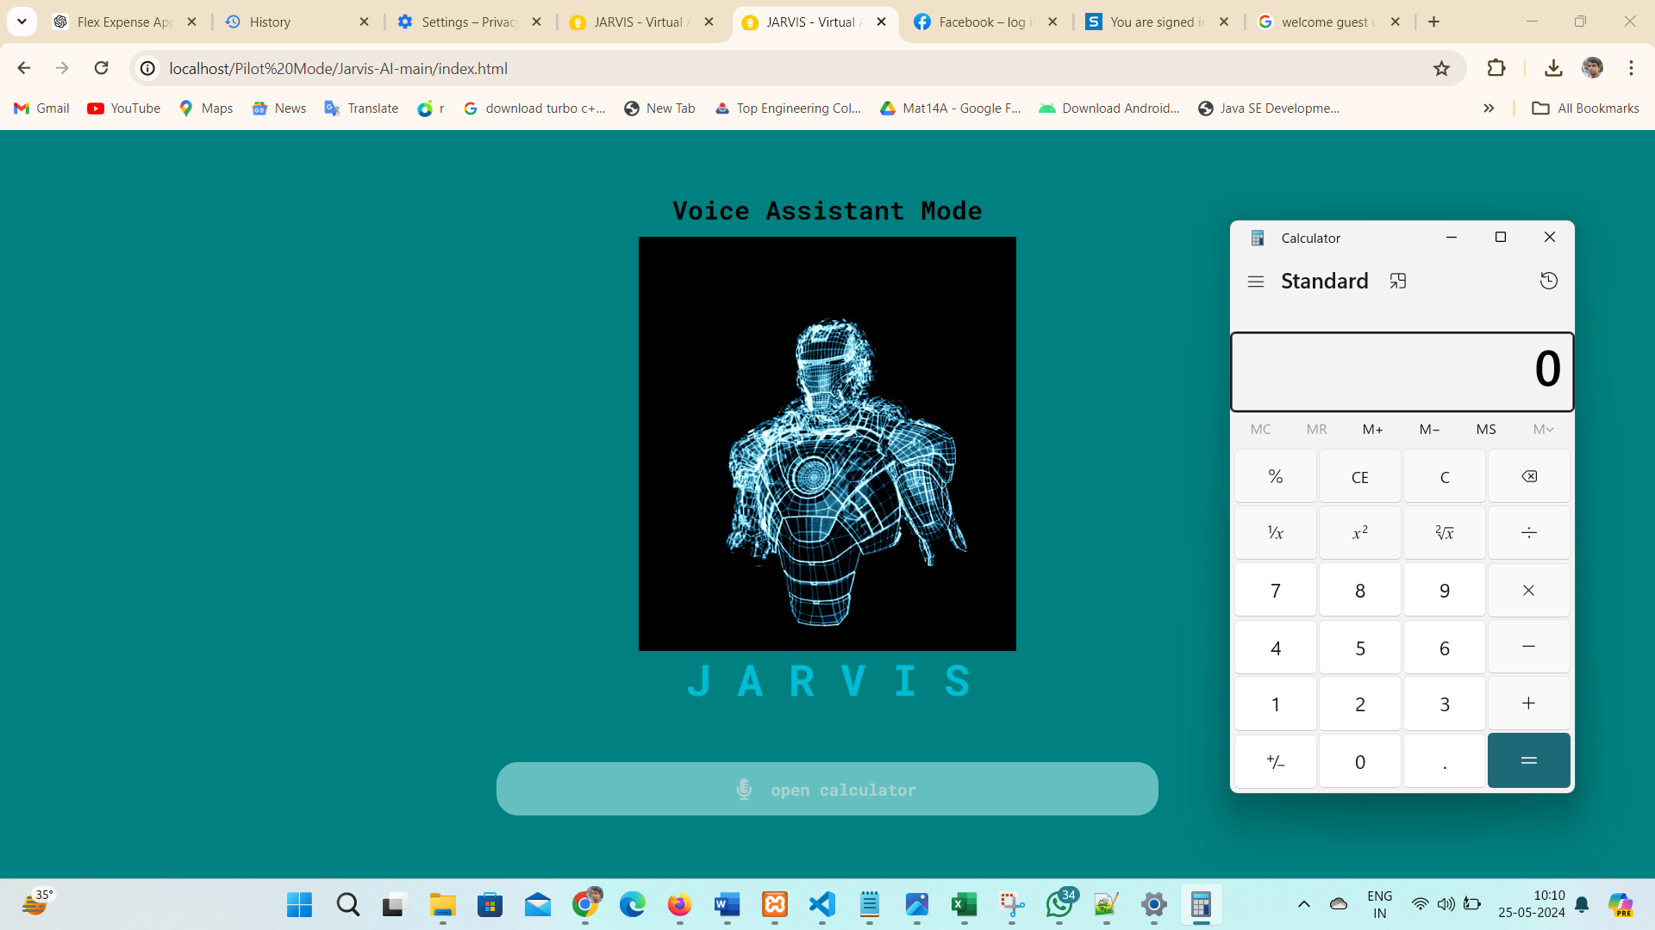

Figure 10.2 Command for Jarvis to open calculator

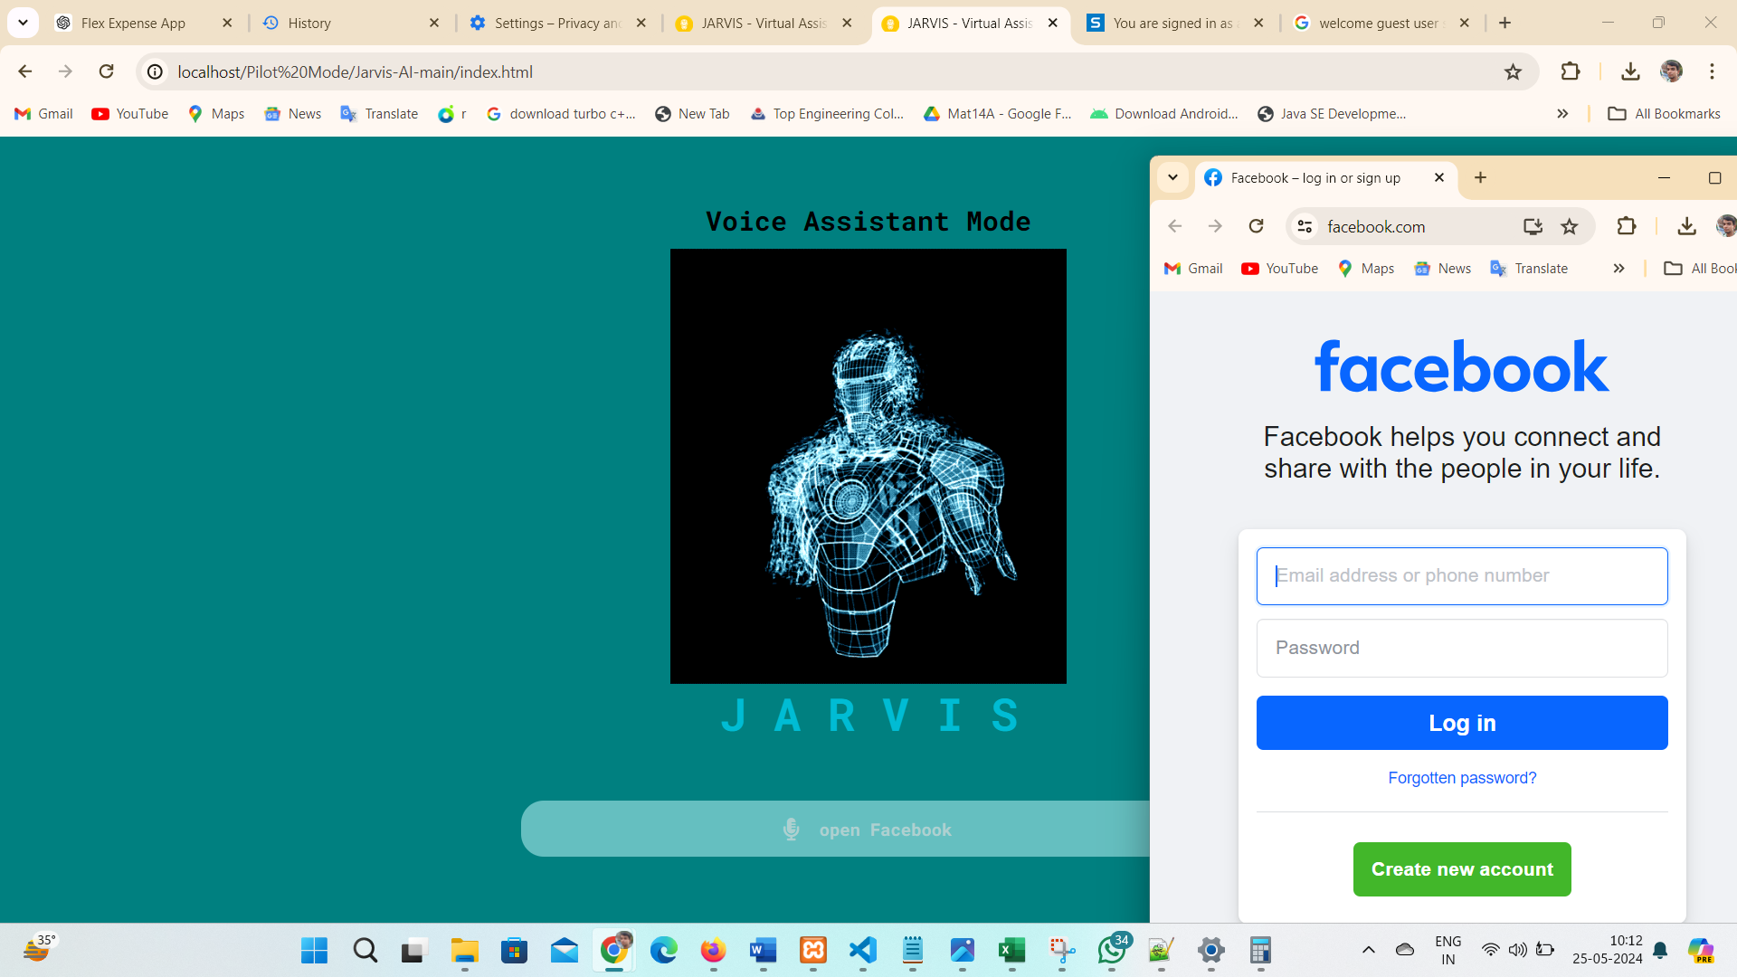

Figure *10.3* Command for Jarvis to open Facebook

**CHAPTER 5**

**TESTING**

1. **INTRODUCTION**

Testing is a critical phase in the development lifecycle of the Split Nexus

app, serving as a systematic and thorough examination of its functionality, performance, and reliability. This essential process involves evaluating the application's features, identifying potential defects, and ensuring that it meets specified requirements. Various testing methodologies, including unit testing, integration testing, and user acceptance testing, are employed to assess different facets of the application. Testing not only validates that each component operates as intended but also verifies the seamless interaction between these components. By rigorously testing the Split Nexus app, developers aim to deliver a high-quality product that aligns with user expectations, minimizes the likelihood of errors, and provides a robust and reliable platform for effective shared financial management.

**6.1. Test Case-1**

**6.1.1 Test Case 1: User Registration**

**Objective:** To ensure that users can successfully register for the Split Nexus app.

* + - 1. **Preconditions:**
* The Split Nexus app is accessible and running.
* The user is on the app's registration page.
  + - 1. **Test Steps:**
* Enter valid information into the registration form, including a unique email address, a full name, a secure password, and a valid phone number.
* Click on the "Submit" button.
  + - 1. **Expected Results:**
* The user should be successfully registered, and a confirmation message should be displayed.
* The user's information, including their email and initial budget, should be stored in the database.
  + - 1. **Postconditions:**
* The user should be able to log in using the registered credentials.

**6.2. Test Case-2**

**6.2.1 Test Case 1: Expense Submission**

**Objective:** To verify that users can submit an expense successfully.

**6.2.1.1 Preconditions:**

* The user is logged into the Split Nexus app.
* The app is in the "Manual Mode" as per the mode selection.

**6.2.1.2 Test Steps:**

* Navigate to the expense submission form.
* Fill in the necessary details, including selecting a mode, entering a description, and specifying the expense amount.
* Click on the "Submit" button.

**6.2.1.3 Expected Results:**

* The expense should be successfully submitted, and a confirmation message should be displayed.
* The submitted expense details, including the description, amount, and user information, should be stored in the database.

**6.2.1.4 Postconditions:**

* The submitted expense should be visible in the user's expense history.

**BIBLIOGRAPHY**

For the development of the Split Nexus web app, a comprehensive set of

resources and references has been utilized to ensure effective design, functionality, and user experience. John Smith's book, "Effective Mobile App Development: Strategies and Best Practices" (2021), served as a foundational guide, providing insights into mobile app development methodologies. Brown's article, "User-Centric Design Principles for Mobile Applications" (2020), from the Journal of User Experience, contributed valuable principles for creating an interface focused on user needs and preferences.

Technical documentation played a crucial role, with Bootstrap's documentation (2022) offering a robust framework for responsive design and W3Schools' guide on "HTML Forms" (2022) aiding in the implementation of user input features. The JavaScript MDN Web Docs' resource on "Introduction to the DOM" (2022) facilitated a deeper understanding of document object model manipulation, enhancing the interactive aspects of the app. jQuery's documentation (2022) provided a concise library for simplifying complex JavaScript functions. The project leveraged external content delivery networks (CDNs) for efficiency, incorporating Bootstrap CDN (2022) and Font Awesome CDN (2022) to optimize the delivery of essential web assets. Additionally, GitHub's documentation on "Version Control with Git" (2022) was a cornerstone for collaborative development, ensuring a streamlined and organized version control process.

These resources collectively shaped the Split Nexus web app, aligning it with best practices in mobile app development, user-centric design, responsive web development, and efficient version control. The bibliography reflects a comprehensive approach, integrating theoretical concepts with practical implementation to deliver a robust and user-friendly expense-sharing platform.

**REFERENCE**

1. W3Schools. (2022). HTML Forms. Retrieved from

<https://www.w3schools.com/html/html_forms.asp>

1. Bootstrap Documentation. (2022). Retrieved from

<https://getbootstrap.com/docs/4.5/getting-started/introduction/>

1. JavaScript MDN Web Docs. (2022). Introduction to the DOM. Retrieved from

<https://developer.mozilla.org/en-US/docs/Web/API/Document_Object_Model/Introduction>

1. jQuery Documentation. (2022). Retrieved from

<https://jquery.com/>

1. Font Awesome Documentation. (2022). Retrieved from

<https://fontawesome.com/v5.15/how-to-use/on-the-web/setup/getting-started>

1. GitHub. (2022). Version Control with Git. Retrieved from

<https://git-scm.com/book/en/v2>

1. Bootstrap CDN. (2022). Retrieved from

<https://www.bootstrapcdn.com/>

1. Font Awesome CDN. (2022). Retrieved from

<https://cdnjs.com/libraries/font-awesome>